Localisation of SRKW J-pod mother calf vocalisations off of False Bay, San Juan Island

Tim Hunt
Beam Reach Fall 2007

In the late afternoon of Saturday 1st September, 2007 a 4-hydrophone array (10m apart) was deployed from the stern of the Gato Verde with members of J-pod in the vicinity, in the hope of getting some solid orca vocalisations. Upon analysis of the data later that evening it was found that some great recordings were made, and evidence of localisation and mother-calf interaction was evident. The results of the data, as well as a narrative of the event are detailed below.

Narrative
The Beam Reach ‘VaTo’ team were approximately 1-2km offshore the west coast of San Juan Island, NW of False Bay following orcas that were southbound inshore of the GV at a distance of approx. 150-200m. The hydrophone array was dragging off the aft port, travelling at a speed of approximately 2 knots. Time was around 5:20pm when we started to hear some solid vocalisations through the GV speakers in the cockpit. A calf then appeared at 7 o’clock (relative to orientation of boat) approx. 80m off the port stern, on a heading towards the GV. Given the direction it was travelling we though it might re-surface right at the stern of the GV, but a few minutes later it re-surfaced at 11 o’clock approx. 20m from the port bow. At the time the calf surfaced at the stern, an individual orca was surfacing approx. 150m abeam from the GV, paralleling southbound (see Figure 2). When the calf surfaced close to the bow of the GV, just moments later at approx. 100m off the port bow (10 o’clock) two, what appeared to be adult individuals, surfaced simultaneously. The calf surfaced again about 100m just ahead of the GV, the two adults surfacing shortly after still at around 100m from the GV. Minutes later off the port bow at a direction of 11 o’clock (distance approx. 150m) the two adult individuals surfaced simultaneously, with the calf now surfacing right behind them. They continued to surface in the pattern slowly pulling away from the GV in an 11 o-clock direction.

Results
Results for the killer whale calls were localised using Ishmael 1.0 software. Speed of sound in sea water was set to 1485 m/s. The localisation co-ordinates were set so that the x-y intercept were at the port stern and thus the GV was in the positive quadrant. Each of the four hydrophones were 10m apart and therefore the first hydrophone would have the co-ordinates (0,-10), and thus is located 10 m directly behind the boat. The 60 second file analysed was 09_01_2007_17_28_54.wav, which had 11 distinct killer whale calls. The results of the localisation co-ordinates of each call are displayed in Table 1, as are the identity of the individuals (based on photo-identification), and the call type made (based on analysis of spectrograms, see Figure 4 & 5). Figure 1 shows a graphical representation of the localised calls from Ishmael 1.0. The four hydrophones are represented by four pink dots in a row, 10m apart and the localised are calls are the white dots to the left of the hydrophones. For example, in call 1, the co-ordinates are (-91.05, -3.95), which is represented by a white dot that is approx. 91m directly from the back of the boat, and 3m away from the boat. Thus at this point in time, a whale was in this position relative to the GV.

Call # | x-axis  co-ordinates | y-axis  co-ordinates | Located in  Figure 1 | Calf or adult call, call type, ID
1 | -91.05 | -3.95 | Yes | Calf, S_2, J38
2 | -89.48 | -6.90 | Yes | Calf, S_2, J38
3 | -75.81 | -10.59 | Yes | Calf, S_2, J38
4 | -70.75 | -14.53 | Yes | Calf, S_2, J38
5 | -85.17 | -8.14 | Yes | Calf, S_2, J38
6 | -75.69 | -8.94 | Yes | Calf, S_2, J38
7 | -53.18 | -11.96 | Yes | Calf, S_2, J38
8 | -57.96 | -8.55 | Yes | Calf, S_2?, J38
9 | -397.06 | 29.13 | No | Adult, unidentified, J22 or J34
10 | -29.35 | -10.37 | Yes | Calf, unidentified/S_4?, J38
11 | -249.10 | 4.10 | Yes | Adult, unidentified, J22 or J34
Table 1. Summary localisations of call file 09_01_2007_17_28_54.wav

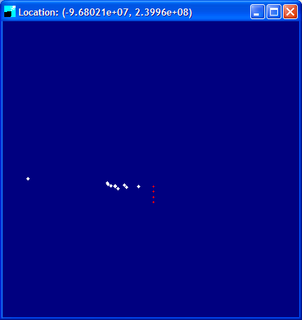
Figure 1. Screen capture display from Ishmael 1.0 of localisation of 60 sec sound file 09_01_2007_17_28_54.wav

Upon viewing Table 1 and Figure 1 and reading the narrative described above we can conclude that the localised calls near the GV are in fact the calf vocalising. It should be noted that as these recordings are being taken, the boat is also moving so not all individual dots in Figure 1 are a single location of the whale. Distances calculated by Ishmael are a very good representation of the calf’s position as the time between when we observed the calf surface at the stern and then again 20m from the bow (localisations show 50-90m from boat), thus it is highly likely that the calf had to swim in this path that is represented in Figure 1, hence supporting the narrative. From Figure 1 you will also see a dot to the far left of the screen snapshot and when time correlated with the photo taken in Figure 2 it was concluded that this was in fact a separate whale, believed to be the mother of the calf that was closer to the boat. We know this because the photo in Figure 2 was taken at 17:29:16 according to the cameras internal clock, and we know that the camera clock has been synchronised with the computer taking the recordings, and so we can be certain of the localisation of this individual. The sound file began at 17:28:54 so we know that the individual in this photo (most likely female J22 or male J34 based on the Photo ID Guide from the Center for Whale Research) is in fact the one that made the call in Figure 1. We concluded that the calf in these localisations is J38, based on the matrilines and ID of J22/J38.
It should be noted that call 9 in the file is not represented in Figure 1, and this is due to the scale of the localisation screen, but it was calculated to be around 400m from the boat. It is believed that this individual in call 9 is the same that made call 10.

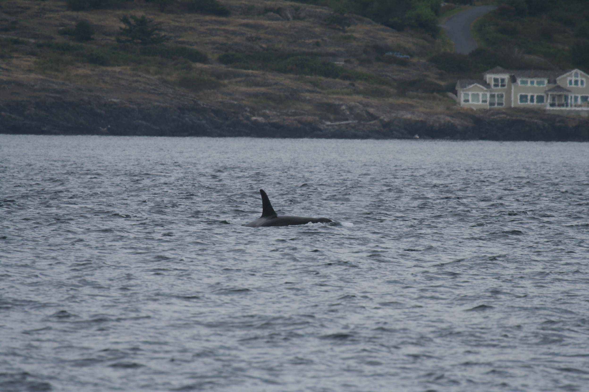
Figure 2. Photo of J22 or J34 taken at 17:29:16 en route southbound off the coast of western San Juan Island, 250-400m abeam to Gato Verde

Figure 3 shows the same individual localisations as Figure 1 but includes three more taken from the sound file recorded 2 minutes later (09_01_2007_17_30_54.wav). Figure 3 is shown so as to further support the narrative in that it was observed that the calf and two adults did in fact come together some short time later and surfaced together. We could not be certain as to whether it was the calf or adults making these calls, but it does appear as though they are heading southbound closing in on each other, as was observed. Further localisation of the calls may in fact support our observations, but for the purpose of this exercise localising a minute worth of calls helped support our observations.

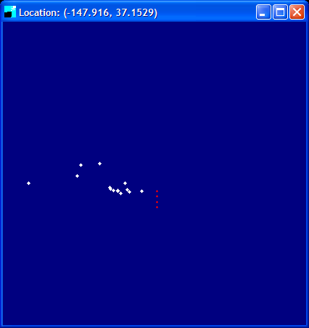
Figure 3. Screen capture display from Ishmael 1.0 of 3 localisations (middle) of part of 60 sec sound file 09_01_2007_17_30_54.wav (incl. data points from Figure 1)

Identification of calls was done with the Ford (1987) call catalogue of killer whales and a call tutor program created by Val Veirs. The first 8 calls made by the calf appear to be S_2, and frequency spectrograms of calls 3 to 6 are shown in Figure 4. These spectrograms were compared with those in the Ford (1987) catalogue and the various versions that were in the call tutor program, and S_2 appeared to be the best fit. Figure 5 shows unidentified calls 9, 10 and 11. Calls 9 and 11 are definitely made by the individual approx. 250m abeam to the GV as they have smaller power spectrums, are mono-syllabic, and sounded further away in comparison to call 10 which was definitely made by the calf. Call 10 was unidentified but appeared to have elements of S_6 in it, but this could not be substantiated.

Figure 4. Spectrogram of call no. 3 to 6 in the 09_01_2007_17_28_54.wav file, believed to be S_2.

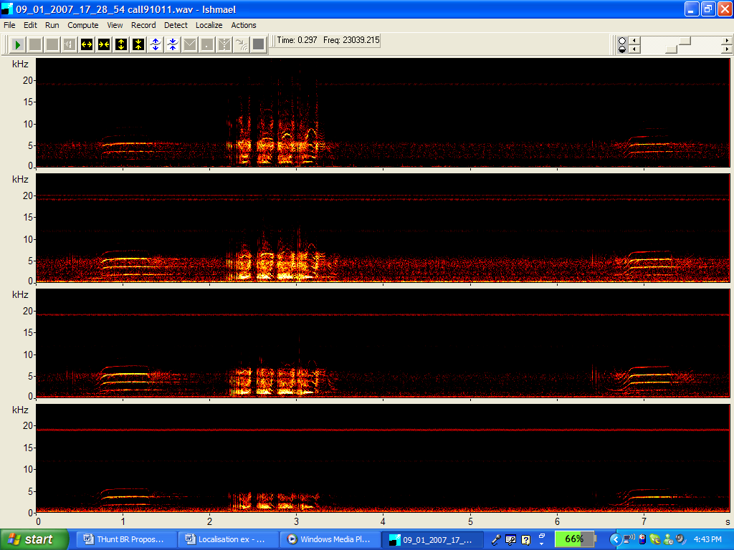
Figure 5. Spectrogram of unidentified J-pod calls (no. 9,10, 11 from 09_01_2007_17_28_54.wav file) showing possible mother/calf localisation (see Figure 1 & 2)

The killer whale vocalisations analysed in Ishmael were of superior quality and are a good representation of what appears to be mother-calf interaction. This is pure speculation, but it was almost as if the calf was deliberately staying away from the mother and checking out the boat, and you can hear the mother calling it as if to say “get back here”. More calls are exchanged, the calf gives into mum, and then meets up with her and its brother (sex of calf J38 unknown). With further superior quality data as presented in this short report, scientists may in fact be able to show evidence of killer whale communication and response.

