Localisation of the SRKW J-pod Mother and calf vocalisation off False Bay, San Juan

Narrative
The calf was first sighted on the port side of the boat travelling directly towards us at approximately 50 meters from the boat. Originally we all thought the calf was J42, based on the comments made by some whale watching vessel operators on the radio. The calf then surfaced at the bow of the boat approximately 20 meters ahead. It resurfaced a few more time before we sighted another whale on the port side of the boat at about 150 meters. The calf headed over towards the adult, whom was shortly joined by another adult whale. Our boat followed the three whales for about half an hour before they were out of sight. As they were travelling they appeared to have a sort of order: 2 adults would surface in unison, followed by roughly 3 or so seconds and the calf would surface behind them.

Hyperbolic Model (localisaion)

17:28:54
Distant calls don’t appear on hyperbolic localization model. Numbered calls are those with strong visual signals. There were other distant calls that don't appear on the spectrum
call # | x-axis | y-axis | notes
1 | -87.72 | -4.45
2 | -91.48 | -6.53
3 | -76.25 | -10.39
4 | -70.73 | -14.52
5 | -85.17 | -8.81
6 | -75.22 | -8.99
7 | -53.18 | -11.96
8 | -57.66 | -8.64
9 | 0 | 0 | not on map
10 | -29.21 | -10.42
11 | -284.2 | -9.13
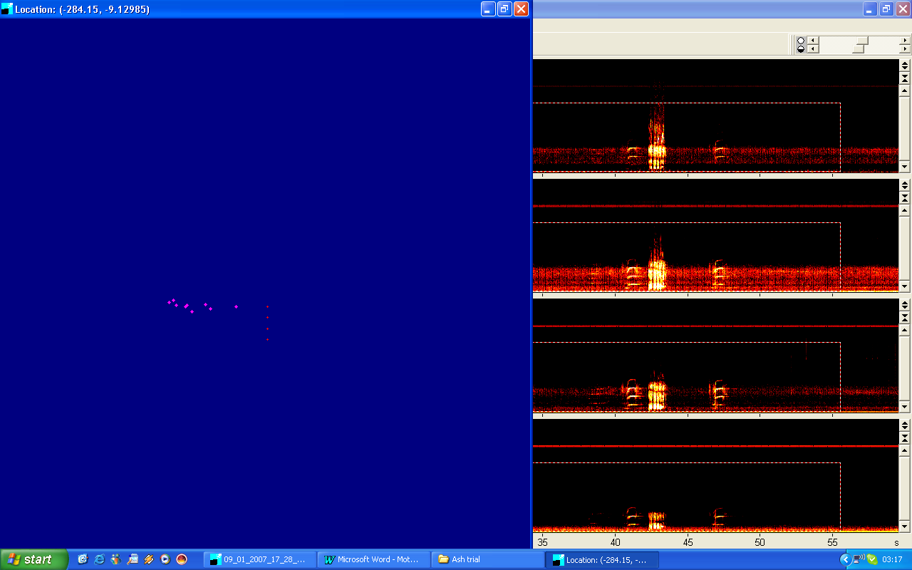Table 1. Coordinates of localization of killer whale calls at 17:28:54

Figure 1. Hyperbolic model of localization of killer whale calls at 17:28:54
17:29:54

call # | x-axis | y-axis | notes
1 | 0 | 46592 | not on map
2 | -10.75 | -2.15
3 | -12.05 | -0.58
4 | -13.11 | 1.42
5 | 0 | 0 | not on map
6 | -11.31 | 8.89
7 | -9.46 | 3.69
8 | -9.32 | 9.85
9 | 0 | 0 | not on map
10 | -7.13 | 29.27
11 | 0 | 0 | not on map
12 | 0 | 0 | not on map
13 | 0 | 0 | not on map
14 | -151.6 | -14.44
15 | 0 | 0 | not on map
16 | -169.3 | -14.99
17 | -166.4 | -10.04
18 | 0 | 0 | not on map
19 | -187.5 | -0.42
20 | -225.8 | 18.72
21 | 0 | 0 | not on map
Table2. Coordinates of localization of killer whale calls at 17:29:54

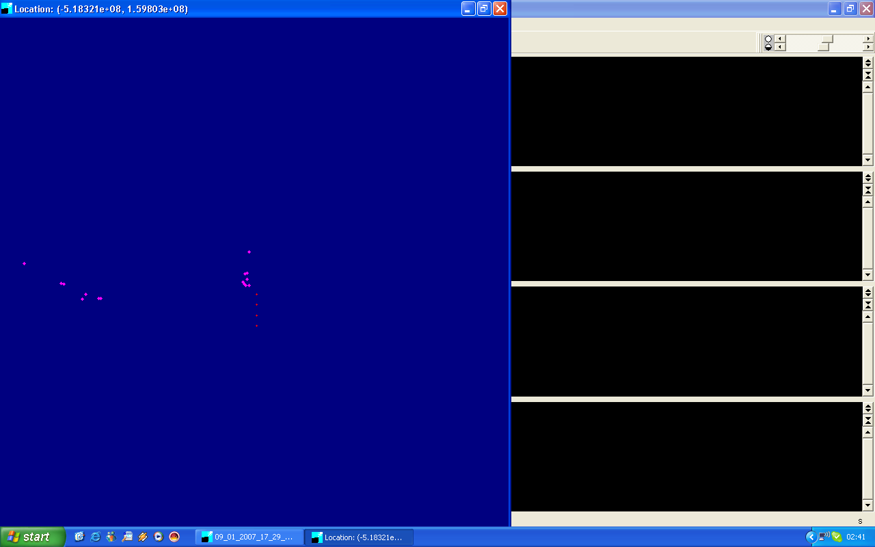
Figure 2. Hyperbolic model of localization of killer whale calls at 17:29:54

By using a hyperbolic model for localizing killer whale calls we can plot the recorded data from the hydrophone and match it up with what the people upon the Gato Verde remember. In figure 1. You can see the whale (calf) location was specifically on the port side of the boat, which is where it was first sighted visually. Then the calf came into view once again at the bow of the boat after a short amount of time, which correlates with figure 2. After a few more surfaces the calf joins an adult killer whale on the far port side of the boat, which is also shown in figure 2. The data recorded in Table 2 shows calls 1-10 X value decreasing consistently ranging from –13.11m to –7.13m. The Y value steadily increases, which correlates with the visual observations of the calf swimming away from the boat from the bow.

Calls 10-20 have a rapidly decreasing X value of –7.13m to –225.8m, which also correlates with the visuals, that the calf was travelling west towards an adult killer whale on the port side of the boat. The Y value was inconsistent indicating undefined direction of travel, possible due to foraging or play-type behavior. Another aspect to consider; the boat was consistently travelling at a speed of approximately 2-3 knots. This could constitute as experimental error, as its uncertain as to whether the calf traveled in the path mapped out by the hyperbolic model, or the boat shifted in a certain direction to make it appear that way.

The recording for 17:29:54 had 9 out of 21 calls that did not appear on the map, and coordinates of (0,0). In our group discussion we concluded that the signal strength was too weak for the program to create coordinations for the map. This is a limitation of the software. We suspect the calls that did not appear on the map were the vocalizations of a distant adult killer whale, whom we saw the calf join shortly after travelling away from the bow of the boat.

Whale Identifying

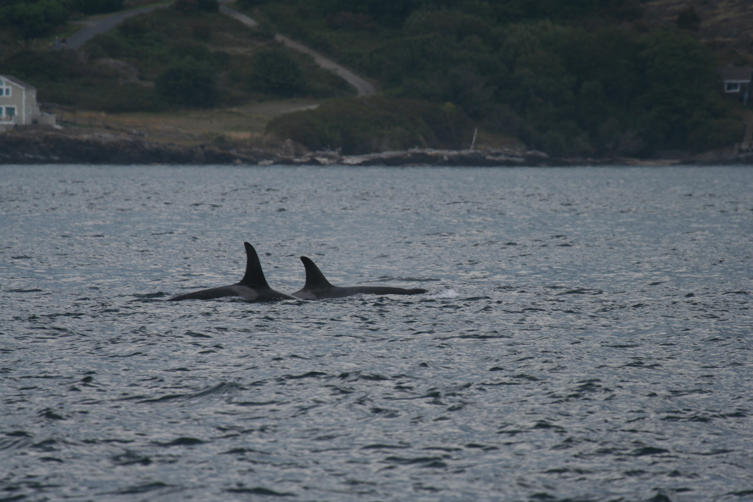

Figure 3. Possibly J34 (immature male) and J22 (female)

