Ground-truthing the impacts of prey abundance and ambient noise levels on foraging behavior in the Southern Resident Killer Whales:
A three-part study

Breanna Walker
Beam Reach Marine Science and Sustainability School
Spring 2012

Background:
Killer whales (Orcinus orca) are one of the most widely dispersed cetaceans on the planet, they can be found in all of the world’s oceans (Dahlheim and Heyning 1999). Killer whale populations are distinct in their foraging tactics and acoustic communication. ** Do I need to describe the location of the Salish Sea?? Please see that below I describe the critical habitat of the SRKW’s ** The Salish Sea is home to two ecotypes of killer whale: transient killer whales and the Southern Resident killer whales (SRKW’s). These ecotypes are categorized by their foraging activates and acoustic dialects. (CITATION). The transient killer whales are mammal eaters and predate anything from harbor seals and sea lions, to other whales and birds. The Southern Resident killer whales are fish eating killer whales, and have a smaller range than that of the transients. Acoustic communication is vital for all killer whale populations, not only to communicate with one another, but also to travel, and most importantly, forage (CITATION). Transient and SRKW foraging tactics greatly differ acoustically because of the difference in prey species for each ecotype. Echolocation clicks are believed to play a critical role in Southern Resident foraging activities, where as transient killer whales do not heavily rely on echolocation clicks to find their prey (CITATION..Bigg 1987?)
NOAA listed the Southern Residents as an endangered population in 2005, it is currently the only population in the world to be officially declared endangered (?? True?? Where could I find a citation for this if it is true???). The recovery plan for the Southern Residents addressed three primary concerns that are still considered to be the largest threats to the population recovery: scarcity of prey (Chinook salmon), exposure to contaminants from pollution, and vessel disturbance (NOAA/NMFS 2005). While in the range of the designated critical habitat (see Figure 1) Southern Resident killer whales feed primarily on Chinook salmon (Ford 1998). Recent genetic studies have demonstrated that 80-90% of the Chinook salmon that make up the SRKW diet are Fraser River Chinook Salmon (Hanson et all. 2010).
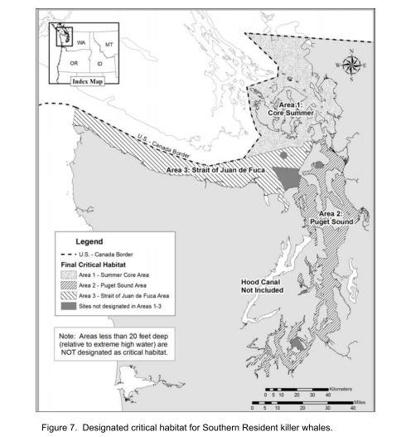
Figure 1: Critical habitat for the Southern Resident killer whales

** This is just my own summary of Sam’s data, I plan to go back tomorrow and add the rest of the scientific data, I just wanted to take some more time to get a better understanding of what it means**A recent pilot study conducted by Sam Wasser shows that the SRKW’s are leaving their summer range with increased levels of Glucocorticoids (GCs; also known as cortisol) than when they arrive in the early spring (….CITATION). This specific horomone.new information is contrary to the previous belief that the killer whales came in from the outer coast deprived of rich food sources and the Chinook salmon runs were fattening the whales for their winter activities of less food.
These results suggest that the Southern Residents are having a difficult time foraging successfully due to limited prey availability. A study done in 2009 by John Ford et. all correlated the population decreases of the 1990’s that were the main reason for declaring the population endangered, were directly correlated to decreases in Chinook salmon abundance.
The current belief is that the amount of vessels are not increasing stress hormones in the whales, but making it more difficult for them to communicate and potentially impacting foraging activities by masking calls. DEFINE MASKING Masking due to increased ambient noise levels from vessel/boat traffic is the biggest concern in terms of vessel/whale interactions at the moment. Particularly, masking of echolocation clicks. GRIFFIN AND BAIN RESULTS It is proven that killer whales raise their calls 1 dB for every dB of ambient noise (Holt et. all)
My goal is to examine prey scarcity and vessel disturbance in relation to killer whale foraging behavior in an attempt to determine which factor most impacts the successful outcome of foraging activities and potentially establish important locations for killer whale foraging activity in the Salish Sea.
Correlating Chinook abundance to killer whale foraging surface behavior and click rates is vital step for determining when and where these whales are feeding. Currently the SRKW critical habitat exists along the west side of San Juan Island in Haro Strait,
I plan to determine salmon distribution by examining three different sources. The local fisherman have some of the best insights into the patterns of the salmon runs, they will be one external source of data. The reports from the fishermen will ideally consist of the amount and kind of salmon they are catching and the location of largest Chinook catches. The Albino test fishery on the Fraser River conducts daily counts for Chinook salmon. This data will be vital in determining Chinook abundance because killer whale population dynamics have been directly correlated to Chinook abundance. Field data will be collected using a fish finer….. The fish finder will be turned on for a short period of time at the beginning of each killer whale encounter. No one on the boat will be able to look at the fish finder,

It is known that the southern and northern resident killer whale populations specialize in Chinook salmon foraging.

- Foraging Patterns of SRKW’s

- Echolocation in SRKW’s

Hypothesis: There will be a significant positive correlation between the amount of echolocation clicks per minute in killer whale calls, foraging surface behavior, and Chinook salmon abundance.

Methods:
Acoustic Recordings:
-1 minute recordings while with whales
-Monitoring the amount of clicks produced per minute
Fish Finder Data
-Snap shots taken with:
-Hero GoPro Camera
OR
-iPhone App (provides less distorted pictures, easier analysis)
-Photo settings:
-1 photo/ minute
-Ideally start at the same time as the acoustic recordings
-Overlap

