Thursday 3rd May 2012
Based on the scientific objectives voiced in the morning meeting, we headed north in the direction of two way points; East Point and West Bank where previous Beam Reach classes (BR112) had conducted research. We departed from Snug Harbor at 10:15am. After approximately three hours of travelling we arrived at East Point where we deployed the CTD, Secci disk, took a YSI reading, made a plankton tow, and listened to the ambient noise by using the calibrated hydrophone.
CTD: The CTD was deployed at the first site to a depth of 60 metres, in keeping with the depth of measurements taken in 2011 by BR112. Having reviewed the CTD profile, the results show that there was a fresh water lens in the top three metres. This was true of both samples taken on this day. See figure 1 below.
Secci disk: The secci disk was deployed on the side of the boat with the most shade (starboard). The disk could be seen clearly until 4.5 metres. Beyond this depth, the black and white sections weren’t distinguishable.
YSI reading: The YSI measured a number of different oceanographic properties including salinity, temperature, and dissolved oxygen. The salinity was particularly interesting because it read 27.3 ppt meaning it was relatively fresh. The dissolved oxygen measured 80%.
Plankton tow: A 20 metre vertical tow was performed off the starboard side of the Gato Verde. Looking under the microscope, many species of diatoms could be observed including Chaetoceros decipiens, Coscinodiscus centralis, Detonula pumila, Thalassionema nitzschioides, and what we think to be Thalassiosira spp. In addition, something resembling the early stages of a developing fish was recorded.
Calibrated Hydrophone: A minute recording was taken at this site, and an AIS screen shot was taken showing all the large vessels within a 26 nautical mile radius. Nothing unique was noted about the hydrophone recording. The hydrophone was calibrated to 125dB.
We arrived at our second way point (West Bank) around 14:15 and immediately started with our physical oceanography sampling. The same instruments were used at this sample site, however, the CTD was only deployed to a depth of 30 metres due to the dramatic change in bathymetry, especially to the northwest.

CTD: The CTD was deployed to a depth of 30 metres. Comparing the profile of the two sites, West Bank showed a small thermocline in the first 5 metres.

Secci disk: At West Bank the visibility was less than the measurement recorded this morning for East Point. At this site, the secci disk was no longer visible after 3.2m.

YSI reading: Between the two sites, the YSI remained relatively constant apart from ‘dissolved oxygen’ which increased to 95%.

Plankton tow: This was the second plankton tow of the day. In comparison to the first vertical tow, there weren’t a lot of organisms to be observed.

Calibrated Hydrophone: Again, a minute recording measuring the ambient noise was taken in addition to a screen shot. The person completing the science log noted that a power boat was observed cruising at time of recording. This casual observation estimated that the boat was 200 metres away. This may have had an impact on the recording.

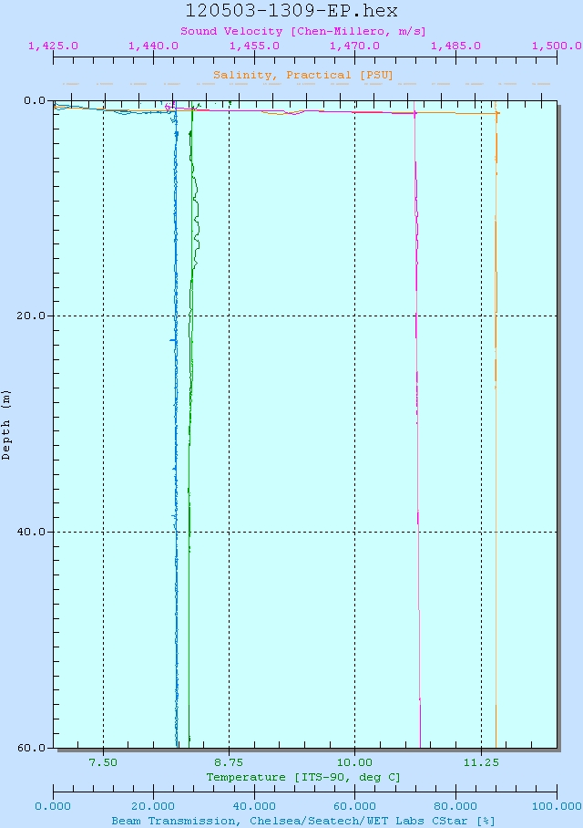
Figure 1: Screenshot of CTD cast at East Point.

