Matthew J. Williams
Beam Reach Spring 2009
Sustainability Project
6-5-09

Striving for Sustainability

The Beam Reach Marine and Sustainability School spends half of the ten week program aboard the sailing catamaran Gato Verde. The time at sea is spent researching Southern Resident killer whales and learning about our impact on the environment. The Gato Verde is an excellent example of a simplified ecosystem. Everything that came aboard and left the boat was measurable which allowed us to become aware of the impact one person can make on the world’s resources. We measured our consumption of water, electricity and biodiesel along with our production of sewage.
When visiting the San Juan Islands, it seems counterintuitive that water is a limiting resource. There is so much water all around the archipelago that it seems as though there should be an ample supply. The truth is that with a relatively small surface area of land on these islands and the rocky substrate, very little of the rainfall is able to be retained in the ground. It is because of its role as a limiting factor, and its necessity for sustaining life, water was carefully monitored and conserved on the Gato Verde.
A major step in reducing our water usage was forgoing showers while living on the boat. That fact alone prevented water from every being a limiting factor while we were at sea. Another opportunity for large amounts of water loss is washing dishes. Cleaning dishes is important to prevent the dispersal of disease. With such close quarters, disease can quickly become a big issue. In order to produce clean dishes without consuming large quantities of water, all food particles and washing with soap was completed with sea water. The Gato Verde has a mechanism that pumps salt water from under the boat in through a faucet in the sink. This enabled us to do the majority of the cleaning without using our fresh water reserves. The only fresh water that was used rinsed the soap and salt water off of the dishes.
In our five weeks at sea, the Beam Reach class of 2009 used a total of 819.8 gal of fresh water. This compared well to the 982.06 gal used by the class in 2008. The class of 2008 had the same number students as 2009, and the only difference in that could be determined between the two is showering. Not one individual took a shower in this year’s program, compared to a handful of showers in 2008. Those few showers that the class of 2008 did take, would greatly contribute to the additional 160 gal used. Baby wipes are a good alternative to showering for those who apply a lot of sunscreen or are prone to perspiring. Since the water usage of 2008 is pretty consistent on a weekly basis, a more likely cause for an increased water usage is inefficient cleaning of dishes (Table 1). Washing dishes is a task repeated at the same rate every day, which would help give similarity in the usage per week.
(Table 1)
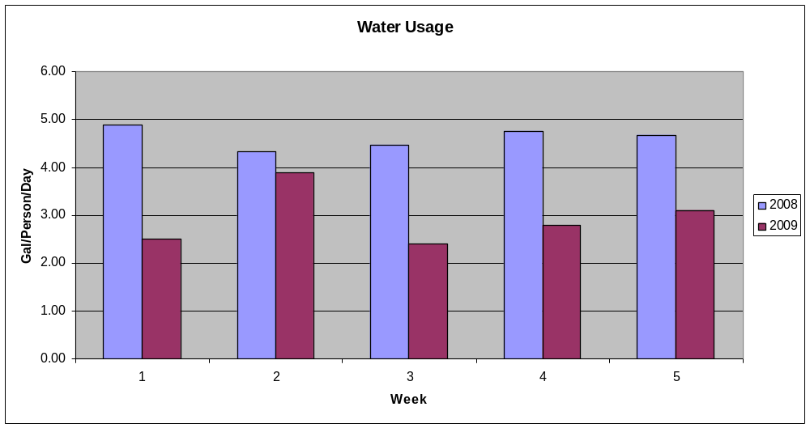
Biodiesel and energy usage on the other hand was not as constant as water. The 2008 program consumed 150.30 gal of biodiesel for their entire trip while only 125.49 gal were used in 2009. Beam Reach of 2009 was actually on pace to use more biodiesel than 2008, but engine failures in week four caused a sharp drop in the propulsion of the boat (Table 2). The lack of traveling in week four allowed the average gallons of biodiesel per day in 2009 to be 3.38 compared to 5.01 in 2008.
Energy usage also varied greatly from week to week. As our time at sea progressed, more time was spent utilizing data on computers, and also is more influenced by the number of people onboard. 2008 consumed 233.10 kWhr during the program while 2009 used 233.18 kWhr. Both of these numbers are estimates though. In efforts to fix the port motor towards the end of week four of 2009, the system that reads energy usage from the port battery to stop working. The port battery is the one that measures both propulsion of the port engine and the usage of the house bank. Energy created by the generator is stored in the house bank to be used for electricity throughout the boat. Due to this fact, our energy usage for the final week was estimated from the pattern of the previous weeks. Only the first 19 days of our time at sea were able to be used to calculate how much biodiesel was consumed for propulsion of the boat compared to the energy used by the housebank. After 19 days, we began having engine issues, which caused our readings of the energy used to become less accurate. The housebank is determined with the assumption that both engines are working equally. When the engine broke, it was obvious that this assumption was no longer valid, and our use of the house bank could no longer be calculated. For our days with accurate energy readings, 8.01 gal of biodiesel was used towards the house bank compared to the 85.12 gal needed for propulsion. This shows that running the motors of the boats is much more costly energetically than using electrical devices. Over 91% of the fuel was used in the motors.
Conserving the biodiesel and energy on the boat is more difficult than water because so many more variables influence its consumption. Tides and currents have a tremendous impact on how much energy must be used to drive the boat. Going with or against the current will influence how much energy it takes to maintain the same speed. Utilizing the wind to help travel is another way to improve gas mileage. A lot of planning can help utilize the forms of energy nature has to offer, but the weather is not limited to our predictions, so it is not always a reliable source. The other key to conserving energy is limiting the use of electronic devices. A common trend on our time on the boat was to keep our computers plugged in while in use. It would be more energy efficient to use the energy sources in the batteries of our electronics before plugging them in to be recharged. Another way to save energy is to make sure that when an electronic device is turned off, to unplug it from the house bank. Even if a device is off, electricity flows through the transformer and consumes energy. These simple tasks will help minimize energy use and will in turn cause us to use less biodiesel.

(Table 2)
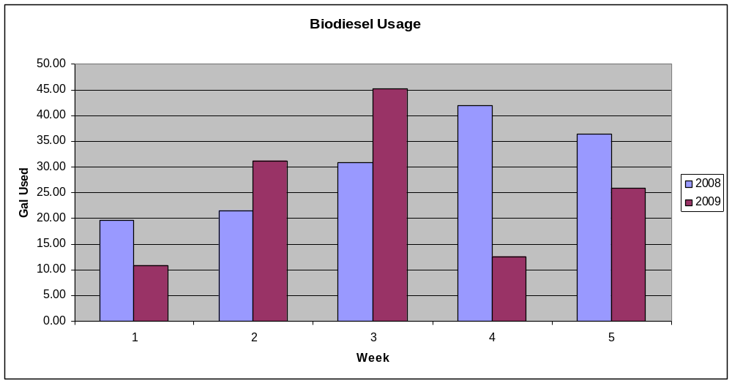

Sewage is the only aspect we measured that we produced when onboard the boat. Everything else was being monitored to ensure that we did not run out of that supply. In the case of sewage, it was important to make sure we did not over flow the holding tank. The 2008 program generated 333.8 gal of sewage which is much lower than the 464.4 gal in 2009. Land heads were used the most during week three, and the 2009 class still produced a lot more than in 2008 (Table 3). Week three was also the week we had the most people onboard, but the land heads should have lessened that impact. The key to alleviating how quickly the holding tank fills is to utilize land heads as much as possible. Eating on the Gato Verde often causes people to eat new and different foods that their body is not used to. Since everyone’s body metabolizes food differently, it is difficult to predict how much sewage will be generated from one program to the next. This causes the incorporation of land heads in navigation plans very important to limiting our need to pump-out our sewage.
(Table 3)
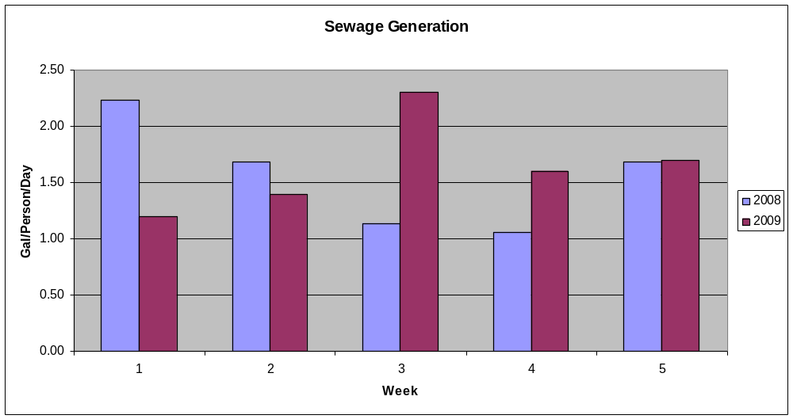
The driving force that causes us to return to land is always the sewage level. The 140 liter tank that holds the sewage on the sailing vessel, Gato Verde, usually fills before a quarter of our water supply is used. We averaged pumping out our sewage every three days throughout our five weeks at sea. Our navigation plans are greatly hindered by the necessity of having pump-out stations close at hand. The nights that we were able moor in the islands north or south of San Juan Island is very limited because of the limited number of pump out stations available.
The only pump-out stations in the waters surrounding San Juan Island are in Friday Harbor, Roche Harbor and a floating manual pump at Reid Harbor on Stewart Island (WPPA 2009). The Reid Harbor station was not installed for the summer season until May 29, 2009, giving us only two days throughout our entire program that we could pump out on Stewart Island. We were also unable to take advantage of the facilities in Friday Harbor unless we were leaving or returning to Friday Harbor Labs to reprovision for the new week. Friday Harbor is located on the east side of the island, and the Southern Residents rarely travel through the San Juan Channel. This leaves Roche Harbor as our sole resource for ridding ourselves of our sewage.
Having Roche Harbor serve as our only option creates more issues than just a limit on our navigation options. Since Roche Harbor does not distribute biodiesel, they do not profit from us repeatedly visiting the harbor. Due to this fact, Roche Harbor has asked us not to visit the pump out station until after business hours so we do not obstruct paying customers. So the ability of the Beam Reach Program to find orcas has been limited by both distance and time restraints due to the production of sewage.
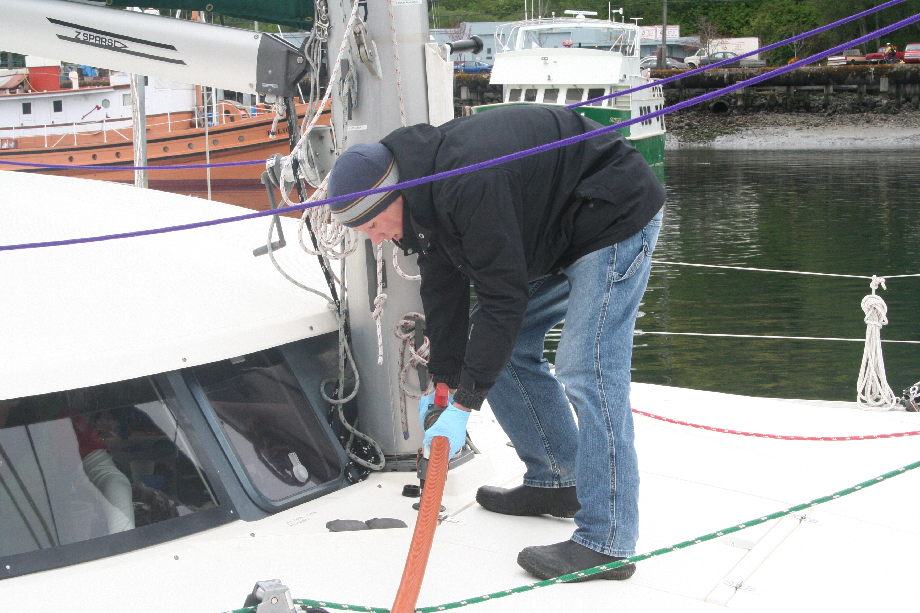
(Matt Williams pumping-out at Port Angeles, WA)
(Unless noted differently, the following three paragraphs obtained information from U.S. FWS 2009) Pump-out stations are such a vital part of Beam Reach’s voyage planning because it is illegal to pump human waste overboard in US waters. The Clean Vessel Act (CVA) of 1992 created a public law mandating boaters to properly dispose of their waste. This act of legislation in 1992 amended the Sport Fish Restoration Act which was initially passed on August 9, 1950. The CVA provides grants for coastal and inland states to provide resources for recreational boaters to dispose of their waste. Projects that can be covered by the CVA can vary between coastal and land locked states. Coastal states have the same eligibility as inland states, but are able to be funded for additional projects due to their increased interaction with aquatic habitats. All states can be funded for: educational programs, determining a location for a pump-out station, any construction, operation or maintenance needed for a pump-out station and any costs compiled with the holding or transport of sewage to a sewage treatment plant. Coastal states can obtain additional funds for: identifying pump-out and dump stations that are operational, surveying the number of recreational boats in their waters that have a toilet on board and expenses associated with the plans of developing new pump-out stations in coastal areas. The purpose of the CVA is to allow the benefits of keeping human waste out of the ecosystem to be preferred worth any additional costs and labor involved in adding or running a pump-out facility.
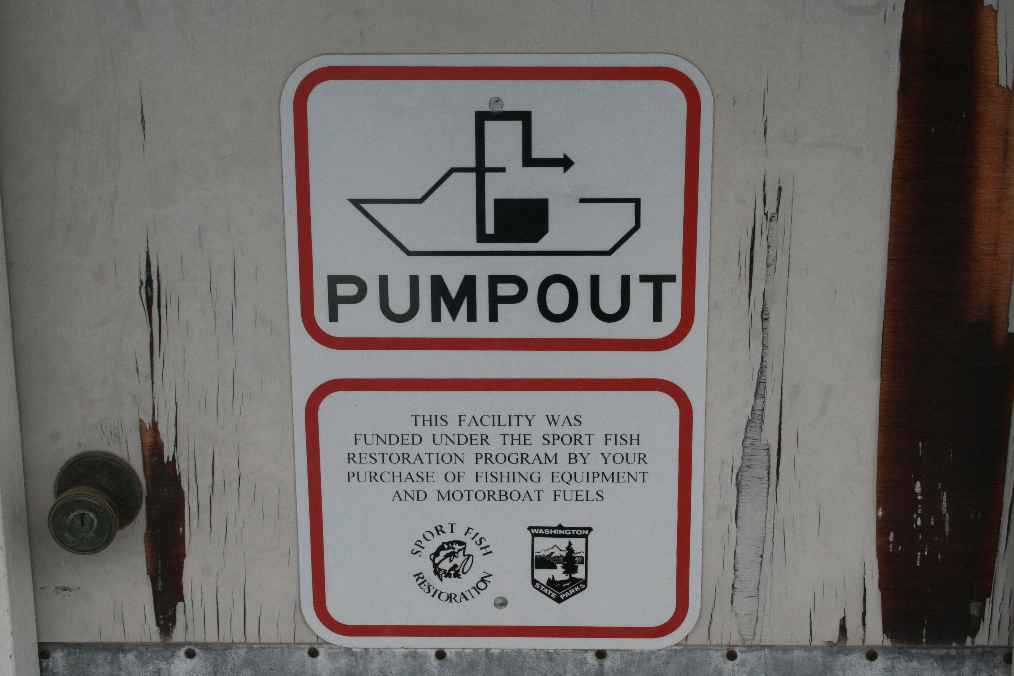
To help with the economic factor of running a pump-out station, shore line property designated for public use can have 75% of its costs covered by the CVA. The most common recipients of financial assistance are marinas and state parks. (Pers. Comm. Hayes) In order to obtain funds from the CVA, there is an application and submission process. In addition to filing out a couple of forms, a Project Narrative must be written. The purpose of the narrative is to: determine the necessity of the proposed projects, measurable objectives that are to be reached within a specific time period and the anticipated benefits from the completed projects. In addition to the parameters of the proposed project, it is necessary to include the people and parameters in which the goals of the project. Maps and charts showing the anticipated work site must also be included. A budget narrative must also be included to help determine the amount of funds given. Any funds given by the CVA must be spent on items specified in the application and any funds not used within three years will be given to the U.S. Coast Guard to be used on Boater Safety programs. All applications must be submitted to the Regional U.S. Fish and Wildllife Services by January 30 each year. Grants are awarded in April of that same year so that there is time to begin the project before the heavy boating season begins Memorial Day Weekend.
There are approximately 14 million registered boats in the United States for 2009. Many of these millions of boats have an on-board toilet, which explains the importance of the CVA. If everyone merely put their sewage in our waterways, it would have a monumental impact on the ecosystem and the repercussions would be felt in our drinking water along with our fishing and boating industries. The importance of clean and healthy water systems is what mandates the federal government allocate an estimated $14 million to be used for the Clean Vessel Act in 2009. The state of Washington received $220,000 of the approximately $13.6 million given by the CVA in 2008. That amount entitled Washington to be the thirteenth highest state to receive funding that fiscal year.
With such an apparent influx of money coming to the state of Washington, it was surprising that there were so few pump-out stations available in the San Juan Islands. The archipelago is a very popular vacation destination in the Pacific Northwest and it would be expected to have the pump-out resources handle the massive amounts of people that visit every summer. Having only Friday Harbor and Roche Harbor available for disposing of sewage in the early summer season creates the possibility of a bottleneck effect at the pump-out stations. If people have to consistently wait to dispose of their sewage, they could become more willing to dispose of their waste overboard to spend more time on the water and less time sitting by the dock.
In addition with the limited pump-out options, the units themselves have often been broken throughout the Beam Reach program. There was an instance in Friday Harbor that the stationary unit on the dock was out of order, so we went to get a portable unit that could be wheeled to the boat, and one of those two units was broken as well (Per. Obs.). One of Roche Harbor’s two pump-out stations has been out of order throughout our entire time at sea (Pers. Obs.). It is understandable that with such a high volume passing through the pump-out unit, that repair are common and inevitable. What does not make sense is why those repairs would not be included in the application for CVA funding. If repairs were included in the budget, spare parts could be available on hand and the machinery could be up and running quickly instead of laying dormant for days and weeks at a time.
The state parks are in a completely different situation than the marinas. Even with 75% assistance with all costs, pump-out projects are still too expensive and time consuming. The purchase of the systems is not the limiting factor, but having a large enough staff required to run pump-outs effectively (Pers. Comm. Hoppe). The CVA does not cover any costs of general staff members. The conflict arises since the state of Washington does not fund the state parks enough to have the manpower to install and maintain pump-out systems that the federal government is willing to support (Pers. Comm. Hoppe).
As the Beam Reach program continues to grow over the years, sewage will hopefully become less of a time consuming issue. The production of sewage is unavoidable, but pump-out stations should become more readily available and in working condition. The federal government is providing excellent incentives to allow people to properly dispose of their waste. It is up to the local marinas and state parks to take advantage of the CVA to help maintain the water ecosystem that their business is based upon.

Citations
Hayes, T. May 8, 2009: Personal Communication.
Hoppe, W. May 21, 2009: Personal Communication.
U.S. Fish and Wildlife Service. May 10, 2009.
http://wsfrprograms.fws.gov/Subpages/GrantPrograms/CVA/CVA.htm

Washington Public Ports Association. May 8, 2009.
http://www.washingtonports.org/downloads/Boat2009.pdf

