Determining call rate and repertoire in matriarch southern resident killer whales: Do matriarchs vocalize more frequently and use certain calls more than other members of the pod?

Preliminary DATA product
Wessal Kenaio
09/13/2007

In this experiment, I will be attempting to determine if matriarchs in the southern resident killer whale population of the San Juan Islands dominate vocal repertoire and have a higher call rate than other members of the pod. I will record various parameters in the field as well as use various methods of analysis to analyze data.

The first parameter will be a recording of calls made by killer whales in the vicinity of our hydrophone. We will attempt to localize individuals and match them with corresponding calls. To localize calls, we will take a picture of a relatively isolated individual and record the time, bearing (of animal relative to boat), and approximate distance from the boat to the animal at that particular moment. An estimate of the number of individuals in the group will also be made at the time of recording to normalize the number of calls made by individuals of the entire group. Doing this will control for calls not matched to a particular individual and normalize the number of calls per individual.

A hydrophone will be deployed and recordings of killer whales in the area will be made. To localize calls we will use a program called Ishmael. Localization is a technique by which we use a computer analysis of files to identify the source location of recorded calls. During a trial period aboard the Gato Verde we sent out a dinghy with an underwater speaker fixed on it. In table 1.1 you can see the estimated location of the dinghy (made by students aboard the Gato Verde) given in distance and bearing (of dinghy relative to Gato Verde). At any moment that distance and bearing were recorded, so too was time. We were later able to match our data with the recorded files. In Ishmael, we opened the file and matched calls with times of recorded distance and parameters. Once we localized the call, if it is in reasonable distance and bearing to the estimated location of the dinghy, we assumed that that certain call was indeed from the dinghy at that moment. This preliminary method will be applied to whales. We will take pictures of an individual whale at a particular location and time and record distance and bearing. We will then be able to match our estimations with localizations made in Ishmael.
 | Ishmael location (of sound source) |  |  |  |  |  | Boat location
time (s into recording) | x | y | distance | bearing (radians) | bearing (degrees) | bearing (adjusted- in degrees) | Distance | Bearing
33 | -30.8925 | 31.6245 | 44.20922479 | -0.77369 | -44.329165 | 44.32916 | 97 | 40
44 | -49.0959 | 24.5568 | 54.89484332 | -1.107005 | -63.426687 | 63.42669 | 85 | 55
53 | -65.7669 | 14.6342 | 67.37540312 | -1.351847 | -77.455143 | 77.45514 | 76 | 70
124 | -76.4626 | 123.722 | 145.4429871 | -0.553564 | -31.716871 | 138.302 | 73 | 130
134 | -14.4166 | 16.1818 | 21.67230968 | -0.727773 | -41.698307 | 148.283 | 83 | 145
143 | -56.269 | 101.17 | 115.765147 | -0.507578 | -29.082053 | 150.9 | 96 | 150

Table 1.1

Photo identification of individuals is an important part of my study. Since I am focusing on calls made by matriarchs, I will have to be able to match calls with animals to identify who is making what calls. In the preliminary collection of data during our first week at sea I was able to take photographs of individuals and positively ID them. Several individuals were identified including J16, J26, J1, J2, J17, and J8 listed below respectively. Animals in pictures were compared with catalogued pictures of individuals (from the Center for Whale Research’s catalogue). The dorsal fin and particularly saddle patch coloration were compared and matched with their respective pictures.

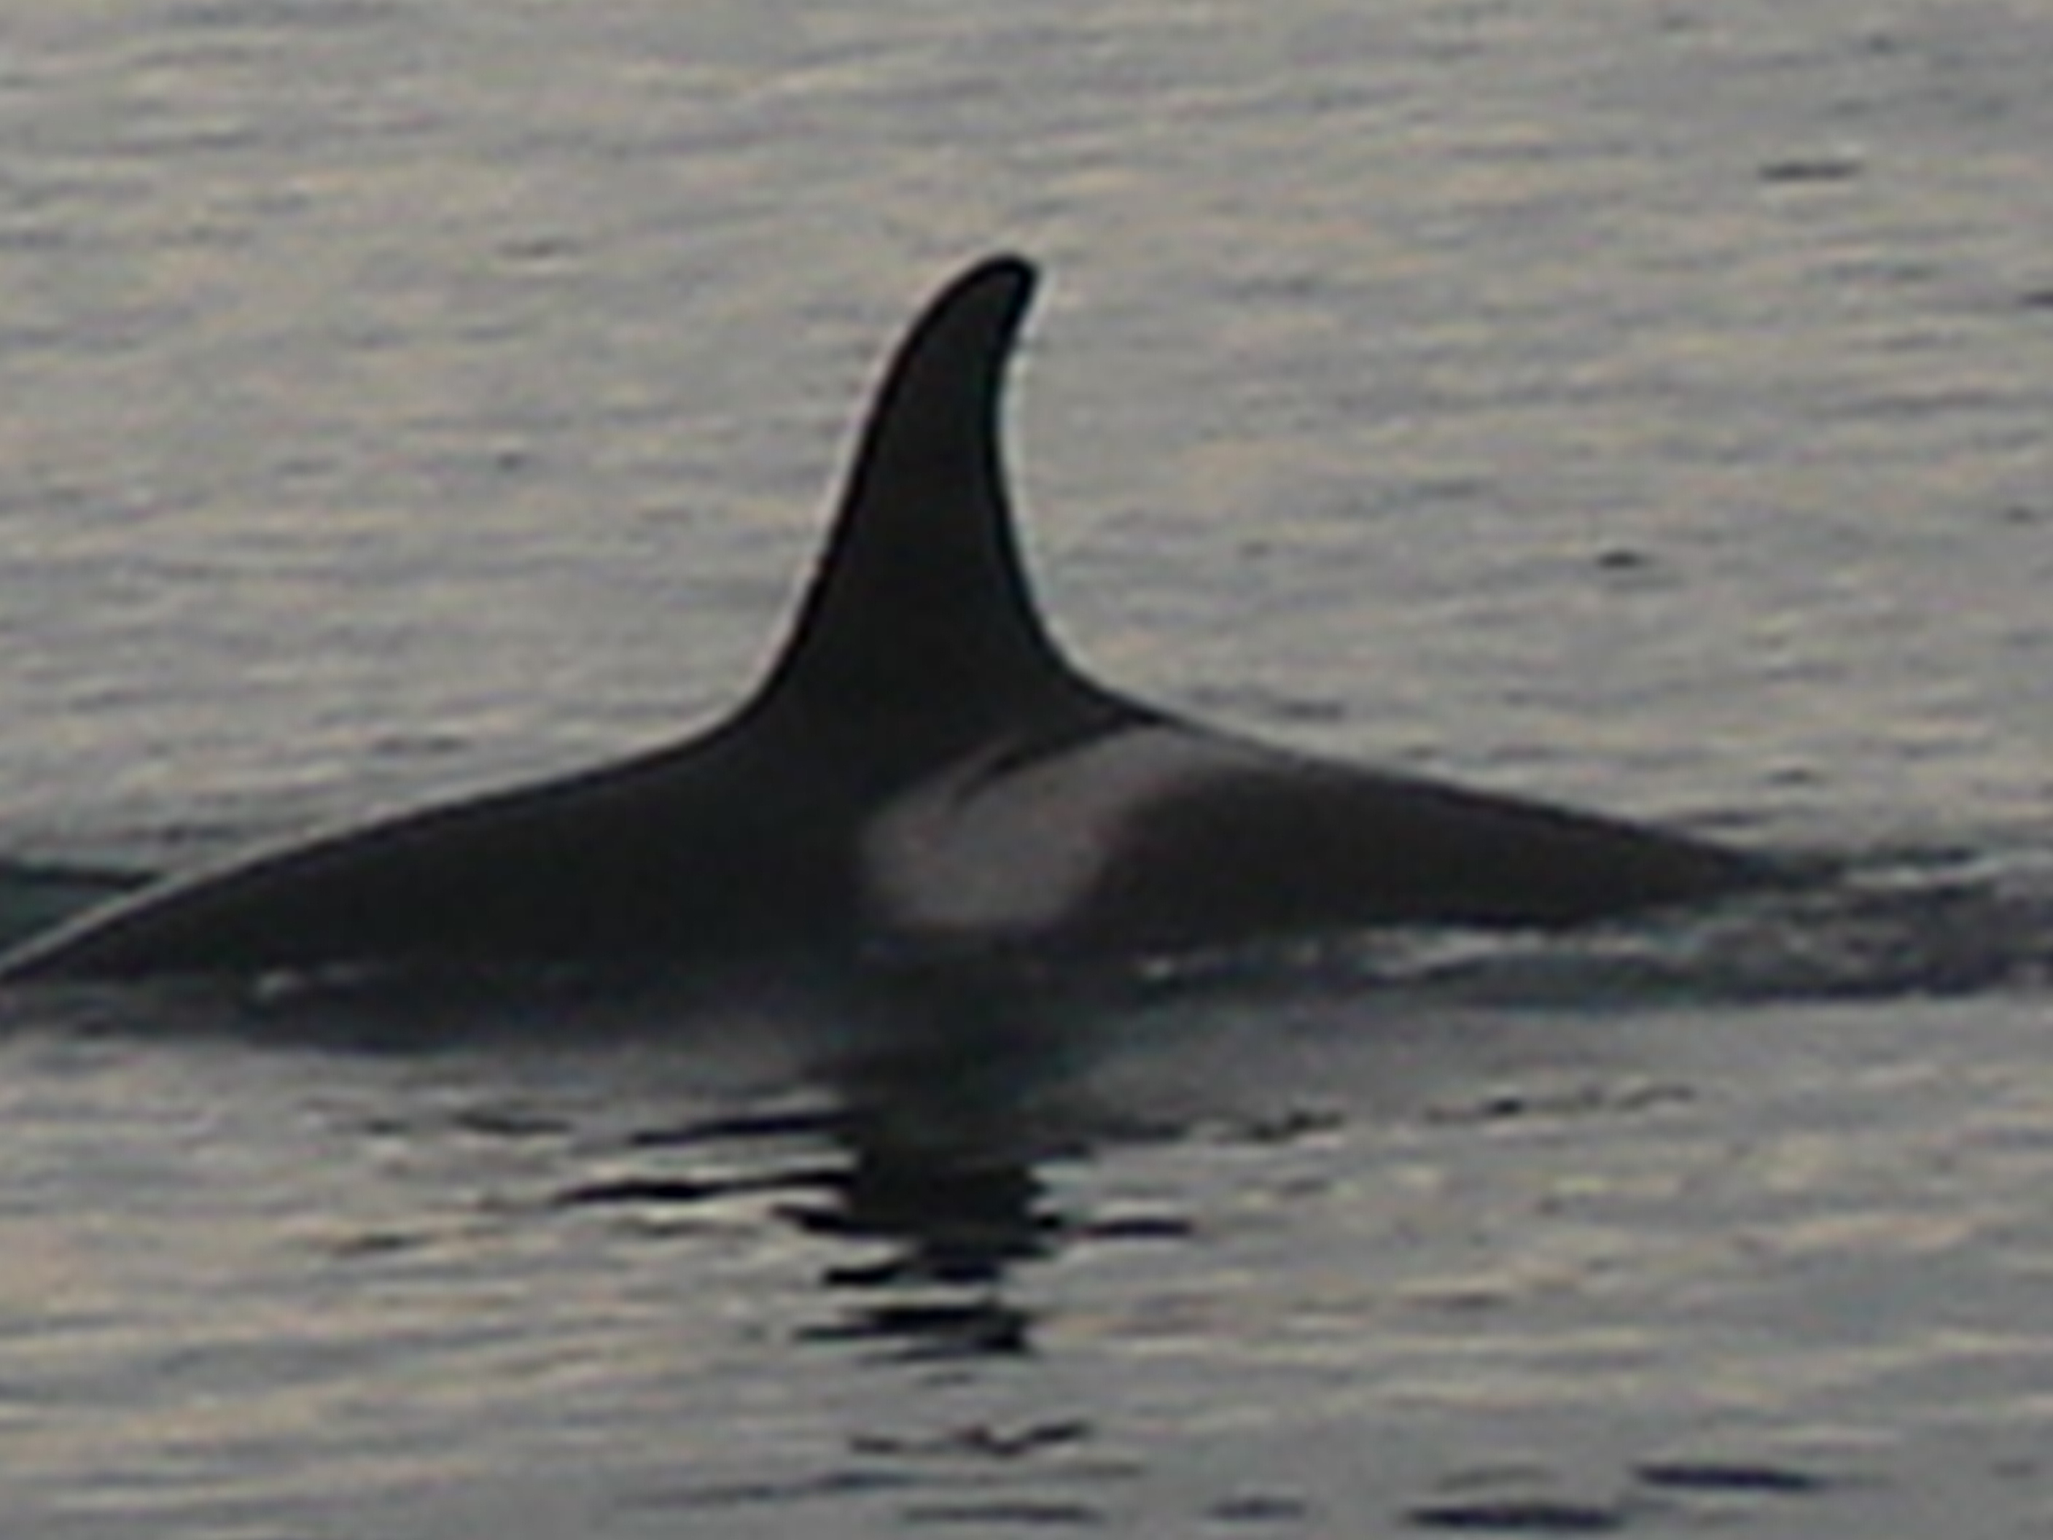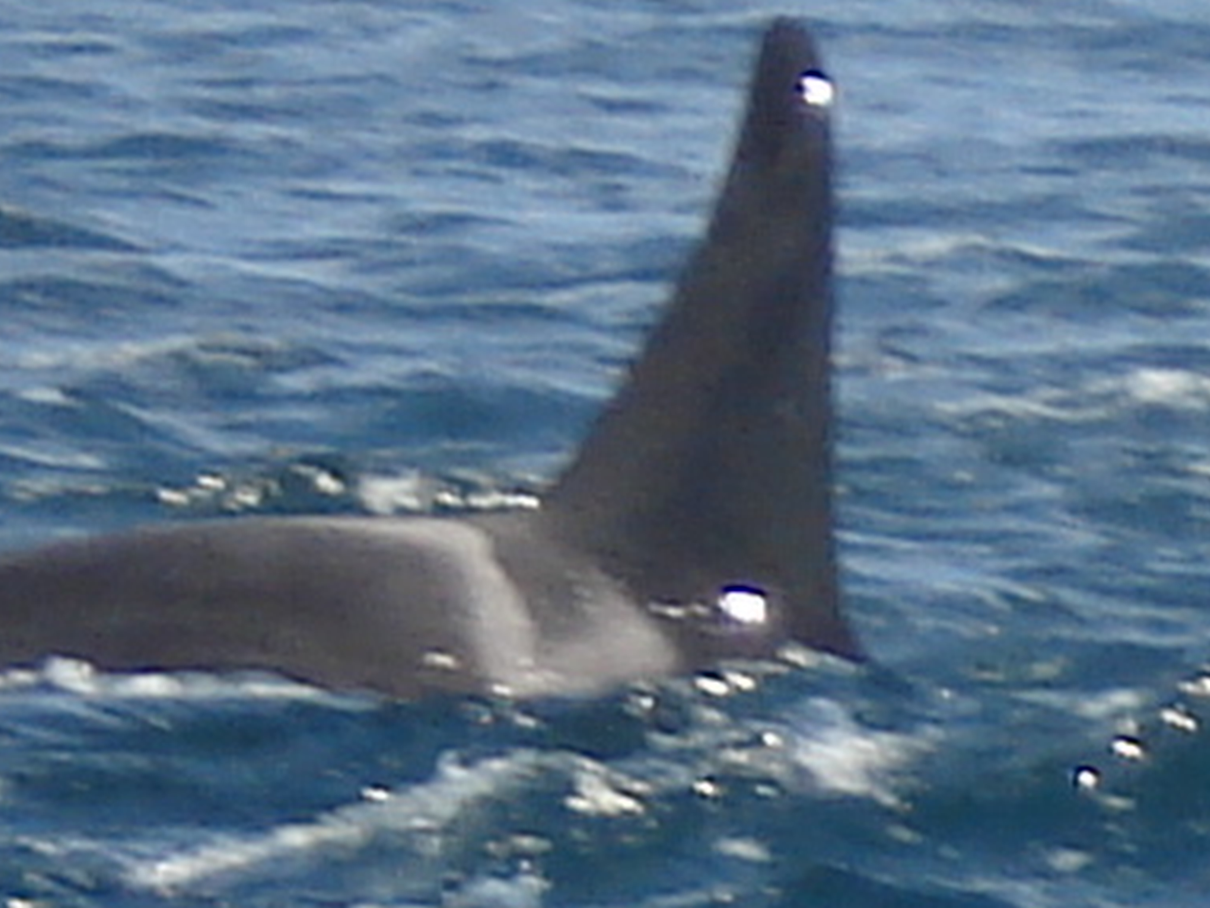
J16 J26

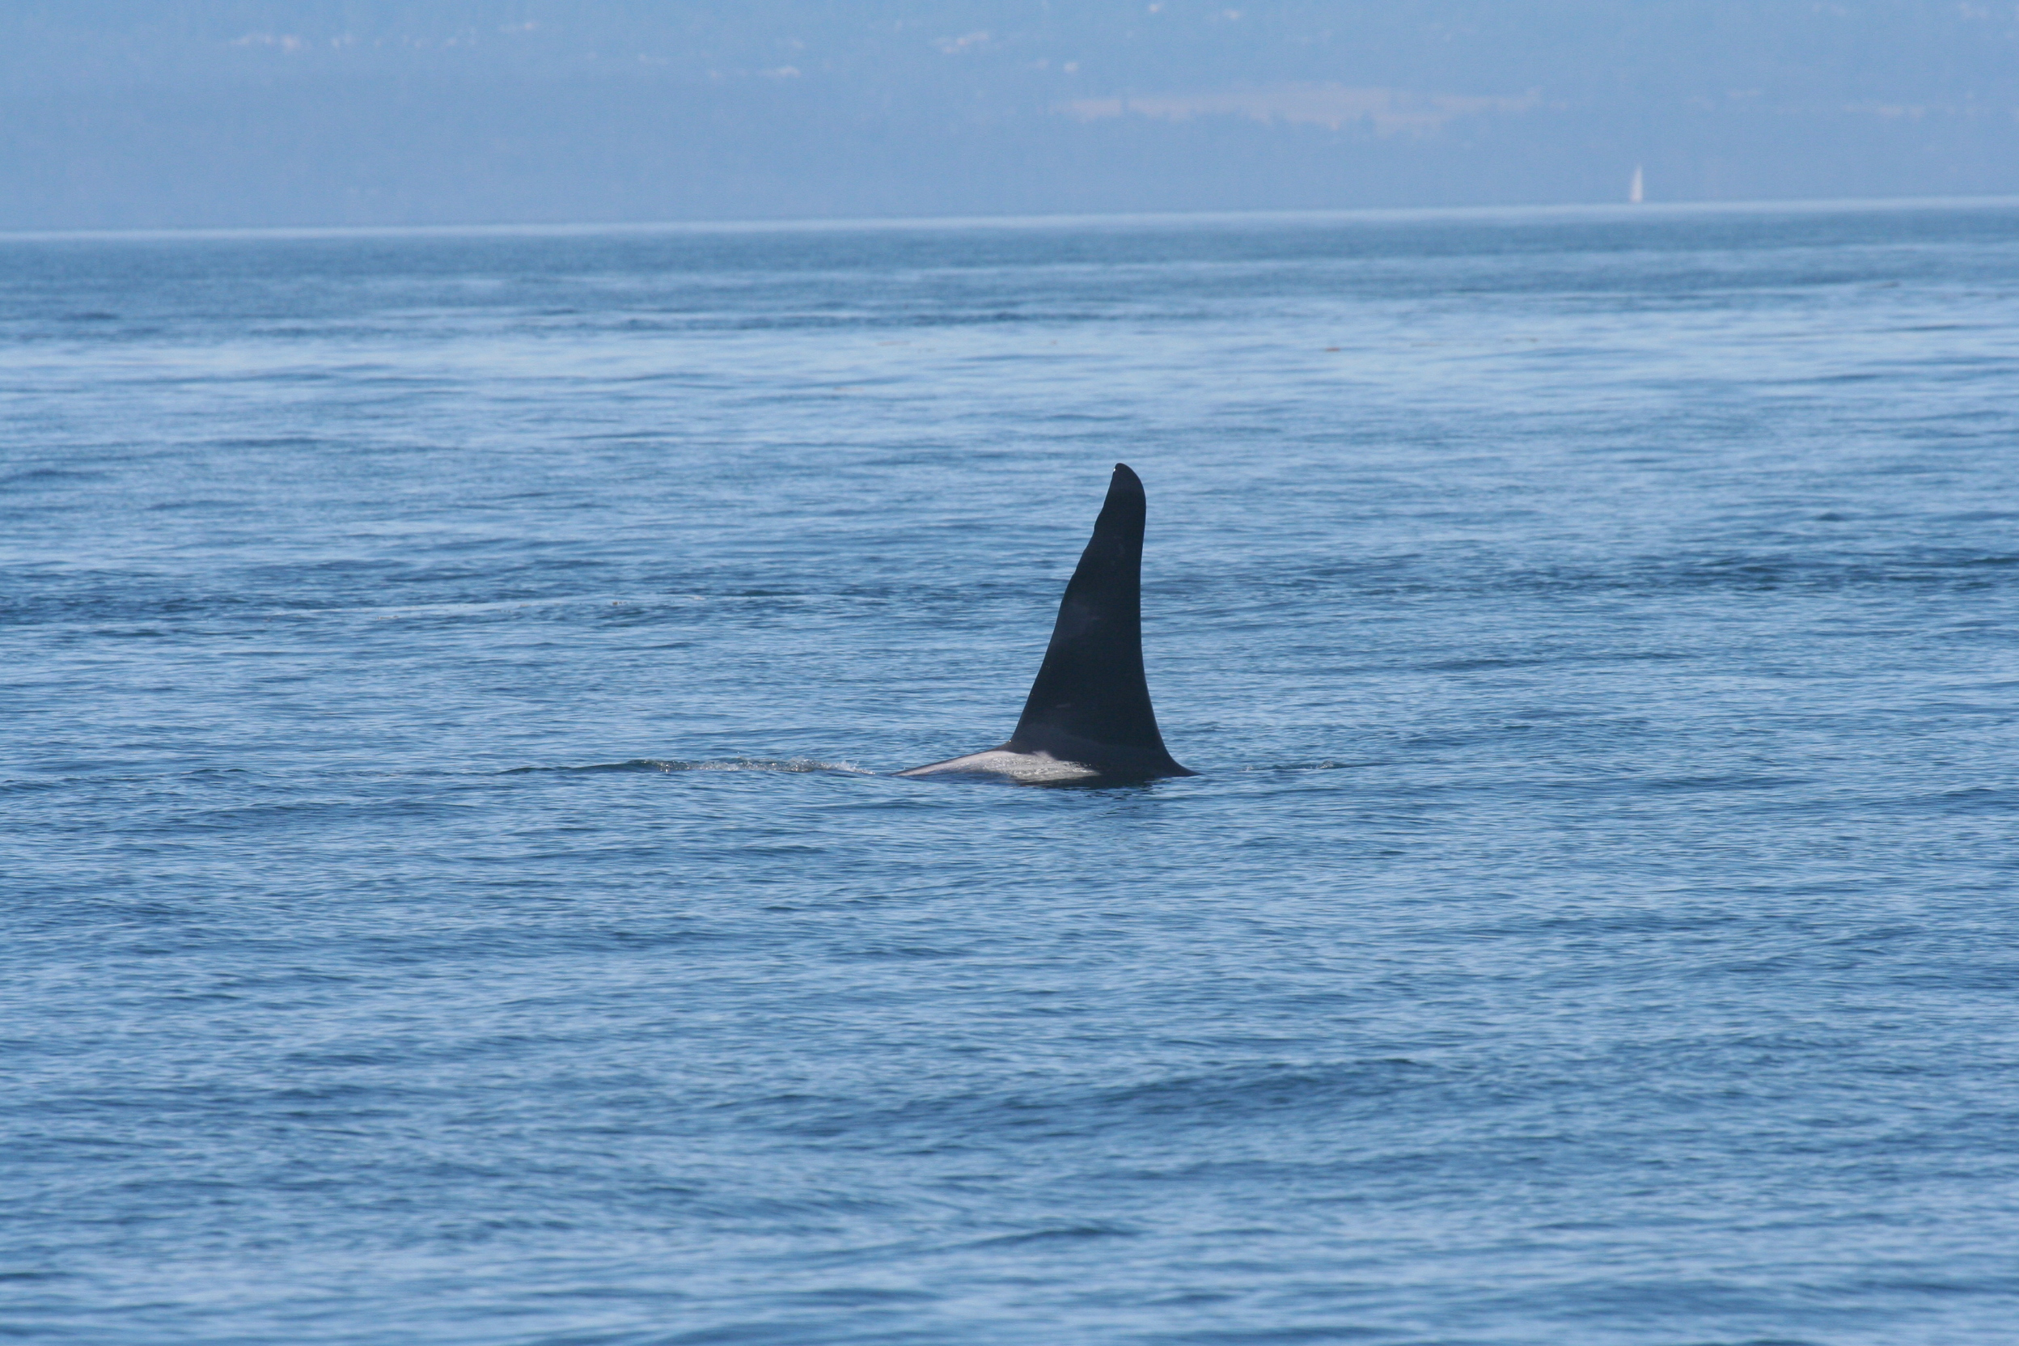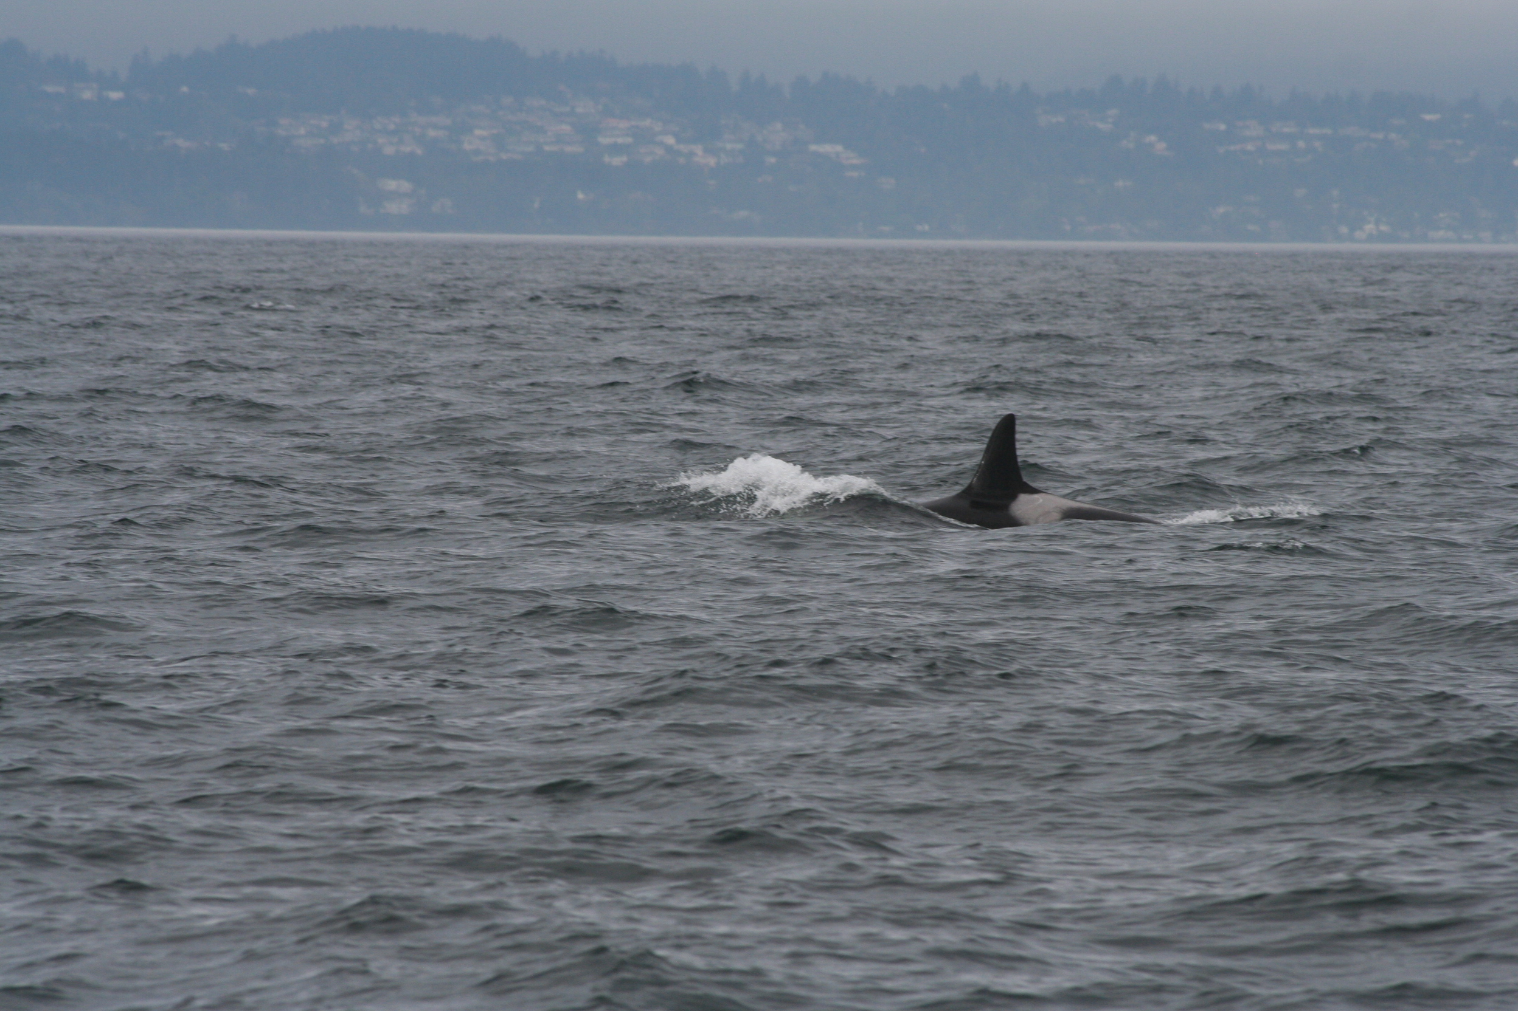
J1 J2

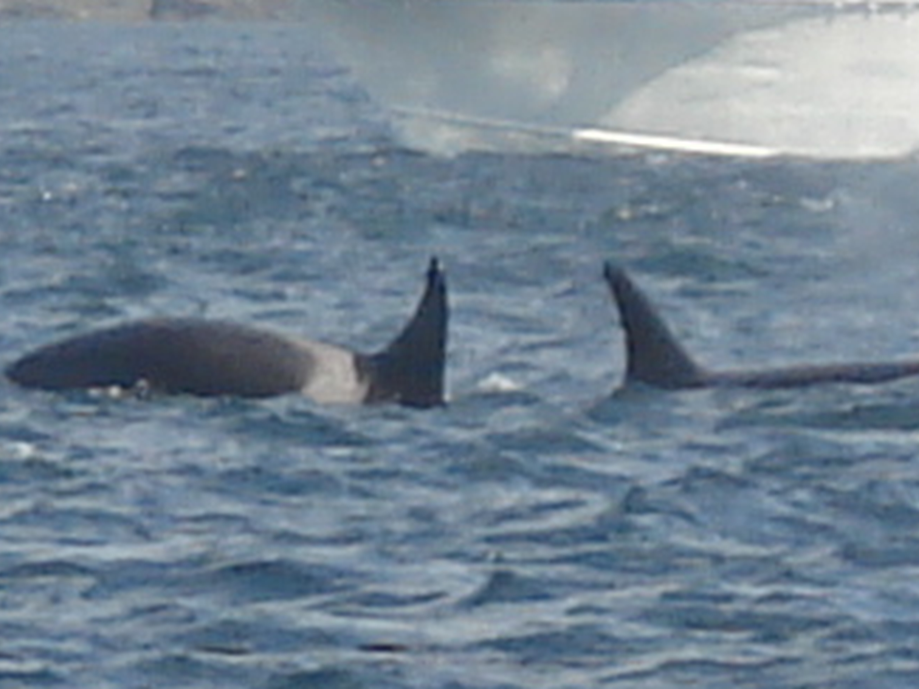
J17 J8

Aside from photographs of individuals, I will need to record the approximate distance from the boat (us) to the whale as well as the approximate bearing of the whale relative to the boat. This information will help us match individuals to discrete calls using Ishmael. In table 1.1 above you can see preliminary recordings taken from a dinghy with an underwater speaker deployed from it. In this mock trial the dinghy would be considered the ‘whale’.

With the preliminary measurements and recordings made from the playback the dinghy was emitting, I was able to successfully use Ishmael to localize the dinghy. In Fig 1.1 you can see that I localized a call made at approximately 42 seconds into the recording of calls coming from the dinghy’s underwater speaker. Ishmael gave coordinates of approximately (-47, 24). With this information, I was able to determine the bearing and distance of the dinghy relative to the Gato Verde. I calculated the distance to be 67 meters at an angle of 77 degrees. This is comparable to the estimated location of the dinghy of 76 meters at an angle of 70 degrees. If the angle measured is within approximately 15 degrees we will consider our estimation accurate, however variation in angle and distance will exist because of human error as well as error in Ishmael.

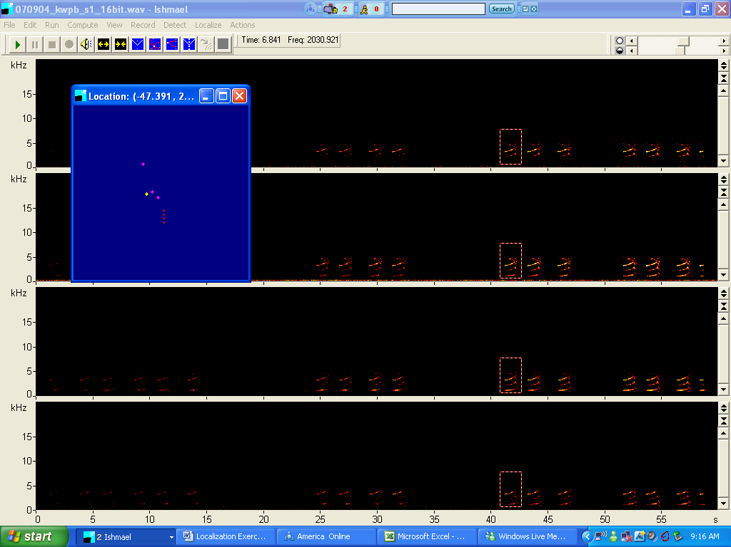
Fig. 1.1

After I have matched certain individuals with particular calls, I will separate the matriarchs calls’ from other animals and determine if the matriarchs have vocalized more frequently than other animals and/or if they use particular calls more than other members of the pod use those same calls. Table 2.1 is an example of what data will be recorded throughout the time recordings of killer whale calls are being recorded. The five students aboard the Gato Verde are all studying various aspects of killer whale acoustics. For this reason, we will be able to work together in data collection. One person will be responsible for physically recording the data in the data sheet along with the time into the recording. Another person will take photos and report the picture number to the person recording data who will record that along with the corresponding time. A third person will estimate the distance to the whale (using a range finder) and the bearing of the whale relative to the boat. The person taking pictures will estimate the approximate number of whales present.

File name | Real Time | Time into Recording (s) | Picture # | Bearing (of whale relative to boat-degrees) | App. Distance to whale (m) | App. number of Whales in group present | Notes
A02.C02 | 10:29 | :60 | 361 | 30 | 45 | 4
A02.C02 | 10:30 | :120 | 362 | 45 | 100 | 4
A02.C02 | 10:30 | :180 | 363 | 90 | 50 | 4
A02.C02 | 10:31 | :240 | 365 | 120 | 75 | 4
A03.C03 | 12:40 | :60 | 402 | 65 | 80 | 9
A03.C04 | 12:40 | :120 | 404 | 100 | 40 | 9
A03.C05 | 12:41 | :180 | 407 | 10 | 90 | 9
A03.C06 | 12:42 | :240 | 410 | 30 | 100 | 9
A03.C07 | 12:43 | :300 | 412 | 45 | 90 | 9
table. 2.1

Once the appropriate data has been recorded, I will localize calls and match them to individuals. I will then graph the number of calls made by matriarchs versus non-matriarchs as well as the frequency of individual calls to determine if matriarchs are vocalizing more frequently or with specific calls more than other individuals are.

Table 3.1 shows the beginning steps of data analysis. After a whale was identified and localized to be the source of a particular call I noted how many calls that individual made per minute. I will then add up the total number of calls made by matriarchs and compare this number with the total number of calls being made by all individuals. I will compare the amount of calls matriarchs made with their proportion of the population. For example, if matriarchs are 25% percent of the population of SRKW’s, and are making 50% of calls, then I know that they are vocalizing more than other individuals are.

File name | Real Time | Time into Recording (s) | Picture # | Identified Whale | Number of calls localized to particular animal | Call Rate (number of calls/min)
A02.C02 | 10:29 | :60 | 361 | J2 | 3 | 3
A02.C02 | 10:30 | :120 | 362 | J2 | 4 | 4
A02.C02 | 10:30 | :180 | 363 | J3 | 2 | 2
A02.C02 | 10:31 | :240 | 365 | J3 | 2 | 2
A03.C03 | 12:40 | :60 | 402 | J8 | 6 | 6
A03.C04 | 12:40 | :120 | 404 | J8 | 4 | 4
A03.C05 | 12:41 | :180 | 407 | J8 | 1 | 1
A03.C06 | 12:42 | :240 | 410 | J10 | 3 | 3
A03.C07 | 12:43 | :300 | 412 | J10 | 3 | 3
table 3.1

The final analysis I will make will be the difference in use of call type. It may be possible that matriarchs are using particular calls more than other individuals are. For that analysis, I will need to identify each type of call being made. In Fig. 1.1, the call being analyzed was determined to be S16 (according to visual analysis from Ford’s call catalogue). After identifying each call type I will compare the number of times matriarchs use each call compared with other animals. For example, analysis of data from Fig. 2.1 shows that matriarchs were using the S16 call more frequently than non-matriarchs (since J2 and J8 are matriarchs and J3 and J10 are not). That would indicate that matriarchs are using the S16 call type more frequently than non-matriarchs. This data is only representative, and a bigger sample size would be ideal and give more solid conclusions.

Identified Whale | Number of calls localized to particular animal | Call Rate (number of calls/min) | Call type
J2 | 3 | 3 | S16
J2 | 4 | 4 | S16
J3 | 2 | 2 | S14
J3 | 2 | 2 | S14
J8 | 6 | 6 | S16
J8 | 4 | 4 | S16
J8 | 1 | 1 | S16
J10 | 3 | 3 | S14
J10 | 3 | 3 | S03
table 4.1

In conclusion, the above data has been fabricated to exemplify my intended course of data collection and analyses. Changes and improvements are possible once organized; methodical data collection begins to take place. I have outlined the manner by which I intend to get results and draw conclusions to the best of my foreseeable ability.

