Localization Exercise
Wessal Kenaio
09/10/2007

Localization is the detection of an individual sound source based on production. In this course we are using hydrophone arrays and time elapsed between recordings to determine the distance and bearing of a sound source. When a sound emits from a single location, the emanating sound will reach each individual array at different times. With the approximate rate at which sound travels through water as a given, in theory we can calculate the distance the sound is traveling to reach those hydrophones. It is based on this theory that we are able to calculate the distance and bearing of the source of the sound. We then enter the data obtained from the hydrophones into a program called Ishmael and determine which location and distance the source of the noise is relative to the arrays.

Before we began taking data from whales (which we would use for our analyses) we did a localization experiment to determine if our localizing program and technique was accurate. We sent out a dinghy (Gatito) from our boat Gato Verde. The dinghy deployed an underwater speaker which played back recorded killer whale calls. There was a hydrophone array at the back of the Gato Verde, which recorded these played back killer whale calls. On the boat we recorded dinghy bearing (relative to boat), approximate distance (from boat), time, and file name. (Since there were no whales around us at the time of this experiment and no other dinghies in the vicinity which would possibly be playing calls underwater, we did not need to take pictures of the dinghy for identification). Once we had recordings of the calls, we opened the files in Ishmael (the program used for localizing in this experiment). Ishmael localizes calls and gives a location for a source of a particular sound. A single file can be used several times (as many times as there are calls in the file) to localize an individual. Fig 1.1 shows a screen in Ishmael in which we opened a file of recorded killer whale calls. Once we opened the file we made a box around a particular call, (time can be determined from the axis at the bottom of the screen). The call that I chose to localize started at approximately 42 seconds into the file. After I highlighted the particular call I wanted to analyze I clicked on hyperbolic location (the second blue key at the top of the page); a smaller screen then opened which showed the estimated coordinates of the source of that call (in this case the dinghy). From those 2 points, bearing and distance from the boat to the caller could be calculated. This method will later be applied to calls made by killer whales. A photo ID in conjunction with estimated bearing and distance would tell us that a particular animal made a specific call.
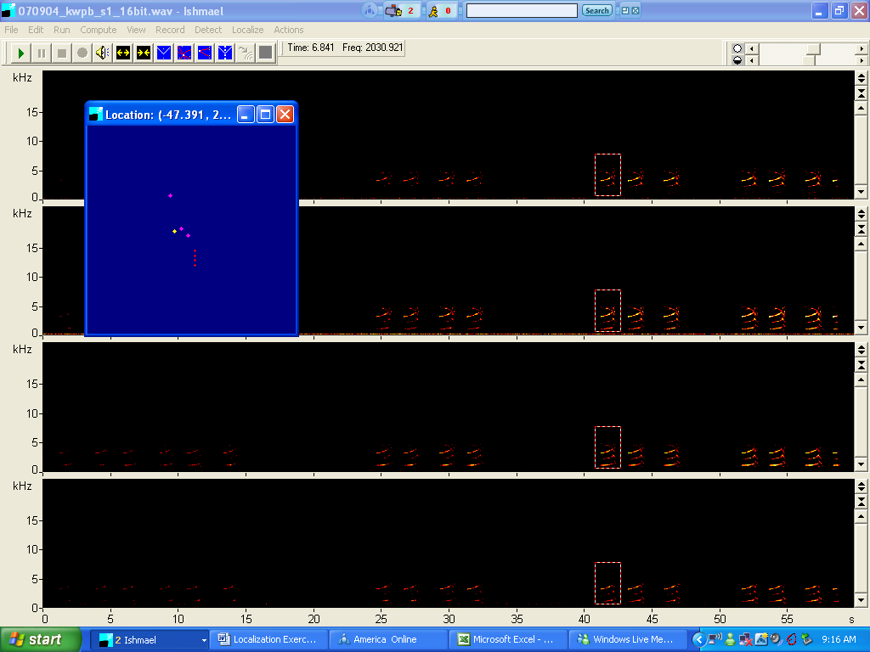
Fig. 1.1

Figure 2.1 is a graphical representation of the coordinates of dinghy location throughout our experiment. Two people were in the Gato Verde recording estimated location and bearing of the dinghy at various times. Figure 2.1 is a representation of several of those coordinates. Using Ishmael to localize calls we later calculated dinghy location for corresponding times. Figure 2.2 is a graphical representation of the calculation of dinghy location based on localization. Although the graphs are similar they are not the same. Biases exist because dinghy location and bearing were estimates made aboard the Gato Verde subject o human error. In addition, Ishmael is a program that localizes an individual based on a 180 degree chart; Error could occur in producing positive and negative results not consistent with actual location (although if particular care is made this error can be avoided).

Fig. 2.1

Fig. 2.2

In conclusion, localization is the location of a sound source based on production. We will use estimated locations recorded from the Gato Verde combined with a localizing program called Ishmael to identify an individual as the producer of a particular call. The study possibilities and analyses that could be made from knowledge of source producer are endless.

