Patterns of Southern Resident killer whale
(Orcinus orca) Movement in Relation to
Tides and Currents

Erin M. Soucy
Beam Reach Marine Science and Sustainability School
620 University Road
Friday Harbor, WA
603-568-3855
esoucy@coa.edu

Introduction

The marine environment is dynamic on both temporal and spatial scales leading marine organisms, from plankton to top predators, to choose habitats that offer them the greatest fitness capabilities (Laidre et al. 2004). Calanus finmarchicus, a copepod, is an important prey item of North Atlantic right whales (Eubalaena glacialis) (Baumgartner et al. 2003). The vertical distribution of C. finmarchicus was measured along with right whale abundance. Right whale sighting rate was correlated with C. finmarchicus abundance and both right whale sighting rate and C. finmarchicus abundance between 90-140m was found to have a similar periodicity to the tides (Baumgartner et al. 2003).
Desired habitats in the marine environment, which is constantly changing, are often not attainable due to physical, temporal or spatial constraints (Laidre et al. 2004). A 2001 study set out to determine if harbor seals exhibit tidal patterns in their at-sea distribution, abundance and foraging success (Zamon 2001). Seal abundance in the water during a flooding tide was significantly higher than the median daily abundance (Zamon 2001). Large fish capture occurred more often during an incoming tide and the median per capita capture rates were greatest in currents during slow flooding (Zamon 2001). The ability to respond to the fluidity of ones environment is thought to improve the viability of a species (Hauser 2006).
Understanding the factors that result in animal distribution is an essential issue in ecology and pertinent to conservation and management. A study in Scotland of coastal dolphins (Tursiops truncates) looked at spatial distribution in relation to the tidal cycle (Mendes et al. 2002). Land based observations estimated dolphin abundance throughout all stages of the tidal cycle as well as dolphin position in relation to the tidal front (Mendes et al. 2002). They found that the dolphins were associated with the tidal fronts and most abundant during the flood (Mendes et al. 2002).
In the marine environment, organisms deal with ever-changing conditions and inconsistent resources that range across spatial and temporal scales. Johnston et al. (2005_{a}) used satellite telemetry, line transect surveys and remote sensing to look at the fine-scale distribution of harbor porpoise (Phocoena phocoena). Line-transect surveys (25 at flood tide and 20 at ebb tide) in a focal region showed that relative porpoise density was significantly higher during flood than an ebb tide phase (Johnston et al. 2005_{a}). Prey surveys showed aggregations of prey along tidal fronts in this region providing a context for the higher densities of porpoise at flood tide (Johnston et al. 2005_{a}).
Marine predators, such as cetaceans, often react to variability in the environment by changes in distribution (Forney, 2000). Predators in the marine environment often forage along oceanographic features that are created by tidal effects and are common areas of prey aggregations. Within the Bay of Fundy, for example, land and boat-based surveys were used to describe the movements of fin (Balaenoptera physalus) and minke (Balaenoptera acutorosrata) whales in an island wake ecosystem (Johnston et al. 2005_{b}). That study found that both fin and minke occurrences were highest during flood tides and lowest during mid-ebb phases (Johnston et al. 2005_{b}). In addition sightings of both whales were concentrated in areas of slower current velocity in the area influenced by an eddy system within the island wake (Johnston et al. 2005_{b}).
Conservation of cetaceans has taken to protecting key habitat areas (Wilson et al. 2004). For this management strategy to work knowledge of what is a critical habitat for the cetacean in question is essential, and this means understanding distribution of the species and what affects it. Management on a single scale either however is unlikely to be able to encompass the wide array of environmental variables that wide-ranging cetaceans face. Multiple scales need to be considered for effective management but first they need to be understood.
One cetacean population of current conservation and management concern is the fish-eating Southern Resident killer whales (Orcinus orca) within Washington, USA and British Columbia, Canada inshore waters. Recent population decline of the Southern Resident killer whales (SRKW) has lead to conservation listings both in Canada under the Species at Risk Act (Baird 2001) and the United States under the Endangered Species Act (NMFS 2005). Designation of ‘critical habitat’ is required under both listings. The Southern Resident killer whales are a very well known group of whales, with over three decades if research on individual and population biology. Three unique eco-types of killer whales have been identified, the fish-eating ‘residents’, the mammal-eating ‘transients’ and the ‘offshores’ (Ford et al. 2000). Every whale is individually identifiable by the shape of the dorsal fin and the unique markings of the saddle patch (Bigg et al.1987; Ford et al. 2000) allowing photo-identification to be used to examine distribution patterns.
While these are well-studied whales, little is known about how they may be affected by the spatial and temporal variability of the tidal cycle, which can be very pronounced within this region. A study that looked at feeding ecology of the Southern Resident killer whales (SRKW) by Felleman et al. (1991) found that the whales foraged more in certain bathymetric regions. They also found that SRKW generally moved with the flood and against the ebb current of the tide (Felleman et al. 1991). They found the killer whales changed the direction of their travel within an hour of slack tide, seven times more often than would be expected by chance (Felleman et al. 1991).
While Felleman et al. (1991) found some evidence of SRKW movement related to the tidal cycle it was anecdotal evidence and the study was focused on foraging ecology. The aim of this study was to use the anecdotal evidence found by Felleman et al. (1991) and design a study to look specifically at patterns of Southern Resident killer whale movement in relation to the tidal cycle.
My objectives for this study were to: (1) Find out if the SRKW move with or against the tide (2) Find out if the strength of the current affects whether they move with or against the tide and (3) Look for a spatial component: Where are they when they move with or against the tide? Is there an effect of current speed where they are on whether they go with or against the tide?

Methods
Data was collected between October 1, 2006 and October 21, 2006 in the waters around the San Juan Islands, Washington aboard a forty-two foot sailing catamaran as part of the Beam Reach Marine Science and Sustainability School Fall quarter. Detection of the Southern Resident killer whales (SRKW) was a combination of the pager network, listening to whale watch boat radio chatter, our own hydrophone detection and simply running in to them while sailing. When we came upon the whales I began collecting data when I felt I could reliably detect which direction they where heading (generally 1000-1500m) and I stopped taking data when I felt I could no longer detect which way they where heading. Waypoints where taken on a Garmin GPS 12XL Personal Navigation device and additional data was recorded in a field notebook. Data recorded included: the time the waypoint was taken, the waypoint number, the date, the predominant group direction of movement, as well as any notes. Waypoints were taken periodically during encounters specifically when any change in the predominant direction was observed. Tidal and current information including, state of the tide, direction and strength of current and the tidal height, was taken from the software program Tides and Currents (Nobletec) using the closest location available closest to where we saw the whales.
A backward stepwise logistic regression was used to test for significance of travel with or against the tide in relation to tidal state, tidal height and current speed (Crawley 2002). Whale orientation with or against was used as the binary response variable assuming a binomial distribution and tidal state, tidal height, current speed and all possible interactions were used as predictors. Non-significant terms were removed sequentially until all remaining predictors were either significant themselves or involved in other significant interactions.
A chi square test was used to test whether or not the whales going with or against the tide varies by the state of the tide (Zar 1999). The null hypothesis for this test was: the probability of the whales going with or against the tide is independent of the state of the tide.
For the spatial component of my objectives ArcGIS v. 9.1 (ESRI) was used to qualitatively evaluate the location of travel with or against the tide and the effect of current speed. The waypoints were projected onto a map of the region, two colors were used, one representing whales traveling with the flow of the tide and the other representing whale traveling against the flow of the tide. In addition a graduated color scheme was used to represent current speeds at the different waypoints on a second map.

Results
Data was collected on October 3, October 10, October 11, October 13, October 19, and October 20, 2006. Sample sizes were as follows: total n=69, flood n=52, ebb n=16, slack n=1, travel with the tide n=38, travel against the tide n=31, travel with the flood n=33, travel against the flood n=19, travel with the ebb n=4, and travel against the ebb n=12.
A backward stepwise logistic regression was run to test for significance of travel with or against the tide in relation to three variables: tidal state, tidal height, and current speed as well as all possible interactions. Complex interactions among tidal variables were apparent from the regression analyses (Table 1). This analysis suggests four significant relationships. First, if the tide is ebbing the whales are more likely to be moving against the tide (p=0.0128). Second, as current speed increases the whales are more likely to travel with the tide (p=0.0356). Third, as tidal height increases the whales are more likely to travel with the tide (p=0.0374). Fourth, when flood and speed are looked at compounded together the whales are more likely to travel against the tide as speed increases during flooding (p=0.0175). Orientation with or against flood and slack tides were not found to be significant predictors (p=0.1292, p=0.9924, respectively). However results suggest that whales travel with the flood and against the slack tides (estimate= -2.6517 and 13.874, respectively). The relationship between whale movement and current speed and tidal height can also be seen in Figures 1 and 2, respectively.
A chi square test was also run to look for the effect of the state of tide on whale movement (with or against). A significant result was found with the whales moving against the ebb more than expected, with the ebb less than expected, against the flood less than expected and with the flood more than expected (Figure 3, χ²=7.989, df=2, p<0.025).
Based on Figure 4, there are a couple of locations where I found the whales to always be traveling either with or against the tide. At Turn Point on Stuart Island the whales were traveling against the tide when I observed them, however we only saw the whales there on one day. Moving south to San Juan Island in the area from approximately Sunset Bay to Smallpox Bay the whales were observed to mostly be traveling against the tide. From Lime Kiln to Deadman Bay they were seen to be generally traveling with the tide. The points furthest inshore along San Juan Island from Kanaka Bay to Eagle Point the SRKW were observed traveling with the tide. In terms of relationships between the whales’ direction of movement and strength of the current Figure 5 shows that the whales seem to travel against the strongest currents. However, initial visual interpretation is misleading. In thirty-one of the data points the whales were traveling against the tide, 39% of these were in currents greater than 1.3 knots and 61% were in currents less than 1.3 knots. In thirty-eight of the data points the whales were traveling with the tide, 63% of these were in currents greater than 1.3 knots and 37% were in currents less than 1.3 knots. Interestingly the black against the tide dots surrounded by red were observed during a flooding tide. This is supported by the logistic regression, which showed that when flood tide and speed are looked at together the whales are more likely to travel against the tide as speed increases during flooding.

Discussion
The ocean is a dynamic ecosystem complete with complex processes. These processes in combination with one another lead to the complex results of this study. This is the first study to look specifically at Southern Resident killer whale (SRKW) movement in relation to the tidal cycle. The results show definite trends in whale movement over the tidal cycle.
A binary logistic regression has greater statistical power than a chi square test, which indicates a relationship but a complex one. It includes interactions between the variables, removes the more insignificant results, and in this case demonstrates that there is some underlying correlation between the factors tested. With something as dynamic as tides, in this study, these underlying correlations are expected. Tidal height for example depends on the state of the tide and current strength is related to tidal height. The first significant relationship from the regression, that if the tide is ebbing the whales are more likely to travel against the tide is supported by the chi square analysis and consistent with the findings of Fellemen et al. (1991).
This study was not without biases. There was limited temporal sampling with all data collected in October between the hours of 11am and 5:30pm and over a limited range of tides. Additionally the statistics used assume independence of the sample points, that is to say assuming that what the whale was doing at point a had no effect on what it was doing at point b ten minutes later. Further studies could improve upon these biases by expanding the study period and time.
There are other factors that were not included in this study that could have an affect on which way the whales travel in relation to the tides. These include prey, bathymetry affects, boat disturbance, behavior state, and larger scale tidal cycles. Assuming that prey has an important impact on where the whales go when effects the tidal cycle has on prey species could greatly influence the patterns seen in the killer whales.
Reasons for the results found by this study may be linked to energetics, foraging ecology, or perhaps related to other physical oceanographic features such as bathymetry. Swimming against the current may slow the rate of travel or increase the energetic cost of travel. An increased benefit such as greater feeding success could account for why we still observe the whales to travel against the current. Salmon is thought to be a major prey item of the SRKW (Ford et al. 1998). Results from studies tracking salmon in the waters surround the San Juan Island, Washington found that the salmon progressed by moving north with the flood and then holding their ground during the ebb (Stasko et al. 1973, 1976 in Felleman et al. 1991). Perhaps the whales’ orientation to the tides is a result of a foraging strategy for salmon, which also orient to the tide.
Conservation and management of this endangered species can be improved as we gain a greater understanding of the environment they live in and how they interact with it. By better understanding what constitutes a desired habitat for the SRKW and how they respond to the fluidity of the marine environment we can better protect ‘critical habitat’ therefore helping to protect the species as a whole.

Acknowledgements

I would like to thank some people for their assistance during this process from initial ideas to final project. First I must thank my instructors, Donna Hauser and Jason Wood for their enthusiasm and willingness to help. Specifically Donna was my mentor and I could not have gotten to this point without her patient guidance and constant encouragement. Thanks to Scott Veirs for his vision of this program and his willingness to allow us to experiment. Val Veirs provided me with technical support in the form of a borrowed laptop and the computer program Tides and Currents which was essential for my data collection. Leslie Veirs provided us with numerous baked goods and moral support. I would also like to thank Peter Westley for his statistical support and assistance on interpreting some complicated results. The research trip could not have happened if it weren’t for our Captain Todd Schuster and relief Captains Mike Dawson and Glenn Gelhar as well as the Gato Verde. My fellow classmates have also been supportive throughout the ten weeks we have spent together in close quarters. Finally, if it weren’t for the constant support and encouragement of my parents and my sister, I wouldn’t have made it to where I am today.

List of References
Baird, R.W. 2001. Status of Killer Whales, Orcinus orca, in Canada. Canadian
Field-Naturalist. 115(4): 676-701.

Baumgartner, M.F., Cole, T.V.N., Campbell, R.G., Teegarden, G.J., and Durbin, E.G.
2003. Associations between North Atlantic right whales and their prey, Calanus
finmarchicus, over diel and tidal time scales. Mar. Ecol. Prog. Ser. 264: 155-166.

Bigg, M.A., Ellis, G.M., Ford, J.K.B., Balcomb, K.C. 1987. Killer Whales: A Study
of Their Identification, Genealogy and Natural History in British Columbia and
Washington State. Phantom Press & Publishers Inc., Nanaimo, British Columbia,
Canada. Pp 79.

Crawley, M.J. Statistical Computing: An Introduction to Data Analysis using S-Plus.
John Wiley & Sons Ltd, England. Pp 761.

Felleman, F.L., Heimlich-Boran, J.R., and Osborne, R.W. 1991. The Feeding Ecology of
Killer Whales (Orcinus orca) in the Pacific Northwest. Pages 113-147 In Karen Pryor
and K.S. Norris, editor. Dolphin Societies. University of California Press.

Ford, J.K.B, Ellis, G.M., and Balcomb, K.C. 2000. Killer Whales. UBC Press,
Vancouver. Pp 104.

Ford, J.K.B., Ellis, G.M., Barrett-Lennard, L.G., Morton, A.B., Palm, R.S., Balcomb III,
K.C. 1998. Dietary specialization in two sympatric populations of killer whales
(Orcinus orca) in coastal British Columbia and adjacent waters. Can. J. Zool.
76: 1456-1471.

Forney, K.A. 2000.Environmental Models of Cetacean Abundance: Reducing
Uncertainty in Population Trends. Cons. Bio. 14(5): 1271-1286.

Hauser, D.D.W. 2006. Summer space use of Southern Resident killer whales (Orcinus
orca) within Washington and British Columbia inshore waters. MS Thesis.
University of Washington

Johnston, D.W., Westgate, A.J., and Read, A.J. 2005_{a}. Effects of fine-scale
oceanographic features on the distribution and movements of harbour porpoises
Phocoena phocoena in the Bay of Fundy. Mar. Ecol. Prog. Ser. 295: 279-293.

Johnston, D.W., Thorne, L.H., and Read, A.J., 2005_{b}. Fin whales Balaenoptera
physalus and minke whales Balaenoptera acutorostrata exploit a tidally driven
wake ecosystem in the Bay of Fundy. Mar. Ecol. Prog. Ser. 305: 287-295.

Laidre, K.L., Heide-Jørgensen, M.P., Logdson, M.L., Hobbs, R.C., Heagerty, P.,
Dietz, R., Jørgenson, O.A., Treble, M.A. 2004. Seasonal narwhal habitat
associations in the high Arctic. Mar. Bio. 145:821-831.

Mendes, S., Turrell, W., Lütkebohle, T., and Thompson, P. 2002. Influence of the tidal
cycle and a tidal intrusion front on the spatio-temporal distribution of coastal
bottlenose dolphins. Mar. Ecol. Prog. Ser. 239: 221-229.

National Marine Fisheries Service (NMFS). Federal Register: Rules and Regulations.
Vol. 70, No. 222. 69903-69912. Friday, November 18, 2005.

Thomson, R.E. 1981. Oceanography of the British Columbia Coast. Can. Spec. Publ.
Fish. Aquat. Sci. 56: 291 p.

Wilson, B., Reid, R.J., Grellier, K., Thompson, P.M., Hammond, P.S. 2004. Considering
the temporal when managing the spatial: a population range expansion impacts
protected areas-based management for bottlenose dolphins. Animal Conservation.
7:331-338.

Zamon, J.E. 2001. Seal predation on salmon and forage fish schools as a function of tidal
currents in the San Juan Islands, Washington, USA. Fish. Oceanogr. 10:4 353-366.

Zar, J.H. 1999. Biostatistical Analysis. Forth edition. Prentice Hall, Inc. Pp.663.

Tables and Figures

Table 1: Results of the backwards stepwise logistic regression. Estimate indicates the direction of relationship where a positive value suggests whale orientation against the tidal variable and a negative value suggests whale orientation with the tidal variable. Statistically significant (α=0.05) factors are indicated with *.
 | Estimate | P
ebb | 6.1826 | 0.0128*
flood | -2.6517 | 0.1292
slack | 13.874 | 0.9924
speed | -3.5985 | 0.0356*
height | -0.6454 | 0.0374*
flood:speed | 4.275 | 0.0175*

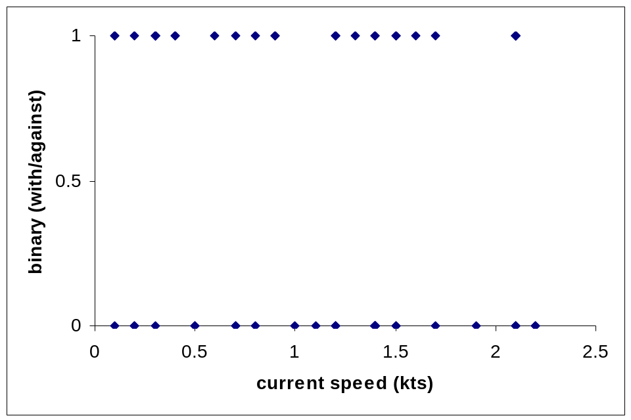
Figure 1: This is the relationship of observations of whales traveling with or against the current depending on speed of the current, where 0=with and 1=against.

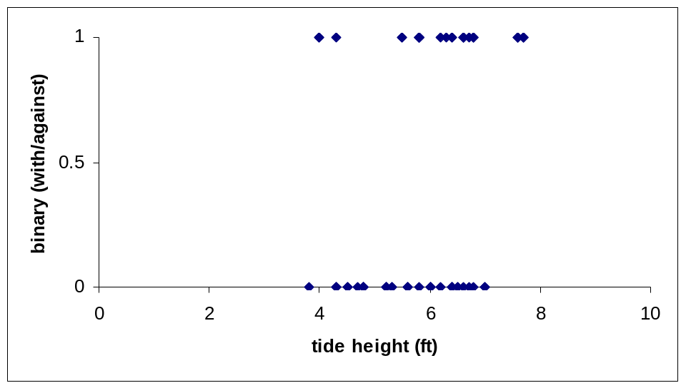
Figure 2: This is the relation ship of observations of whale traveling with or against the tide depending on the height of the tide, where 0=with and 1=against.

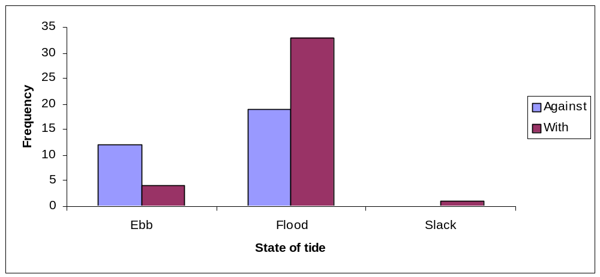
Figure 3: Frequency histogram of observations, depending on state of the tide, of whales traveling with (purple) or against (blue) the current. Sample sizes for each are: flood n=52, ebb n=16, slack n=1, with n=38, against n=31
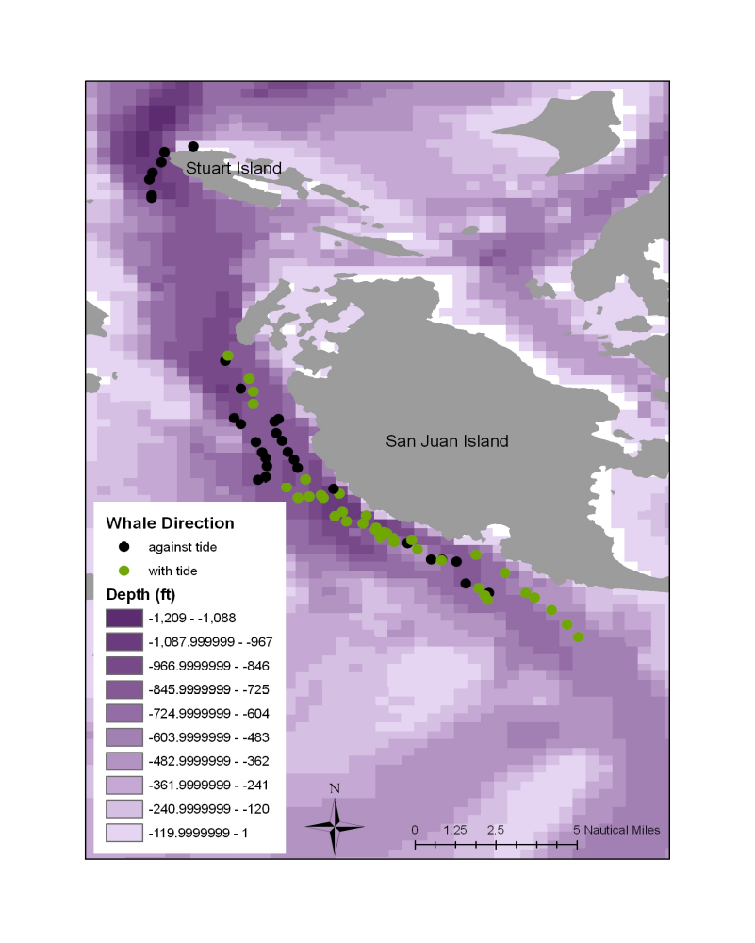
Figure 4: Observation locations of whales traveling with (green points) or against (black points) the tide, overlaid on bathymetry. San Juan Island, referenced in the paper, is noted.

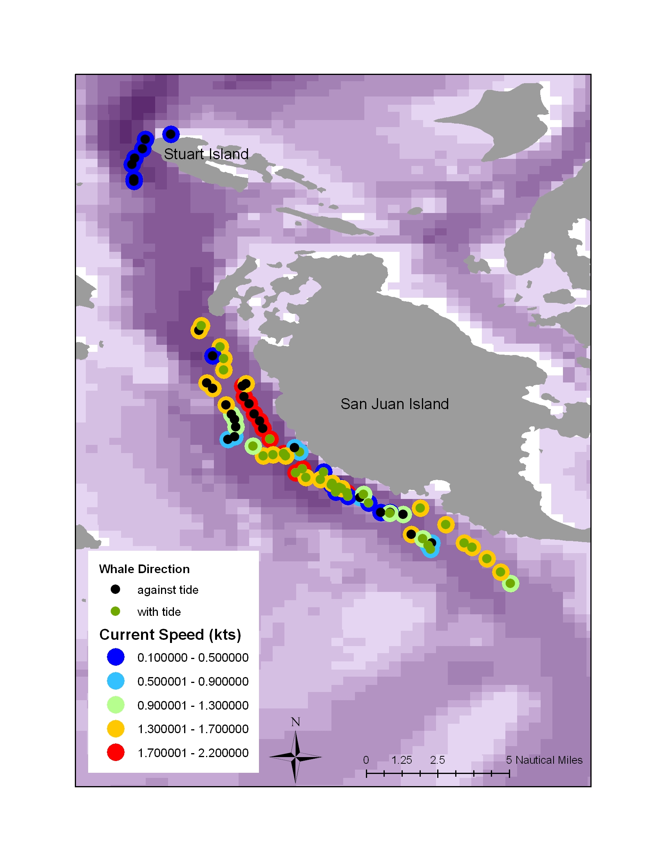
Figure 5: Observation locations of whales traveling with (green points) or against (black points) the tide, overlaid on bathymetry. Current speed is also included with the greatest current speed shown in red and the slowest current speed shown in blue. This map demonstrates the complex relationship between where they travel with and against the currents.

