Determining patterns of whistle use in southern resident killer whales, Orcinus orca

COLLEEN BARRY

Beam Reach Marine Science and Sustainability School

Friday Harbor Laboratories, University of Washington

620 University Road

Friday Harbor, WA 98250

colleen.p.barry@gmail.com

Introduction:

Killer whales (Orcinus orca) are found throughout the world’s oceans in various group sizes, social structures and behavioral patterns. In the northeastern Pacific three main ecotypes of killer whales coexist, fish-eating residents and offshores, and mammal-eating transients. While commonly differentiated by their difference in prey type, these three groups also differ socially, genetically and acoustically (Bigg et al. 1990, Ford 1991, Ford et al. 1998). Further, within the resident population, there are four distinct clans, delineated by their unique vocal repertoires. The northern residents are comprised of A, G and R clans, while the southern residents comprise the J clan. Even more specifically, the J clan is divided into three pods, J, K, and L. Pods are structured through maternal lineage, thus members of each clan are closely related (Ford et al. 2000).
The southern resident clan maintains strong matrilineal bonds. Neither males nor females disperse after birth and instead remain with their mother throughout their lifetime. Pods are thought to interbreed to avoid inbreeding (Ford et al. 2000). Whales habitually frequent the Puget Sound, particularly Haro Strait. This area is rich in nutrients and has a stable presence of salmon throughout the year, with fluctuations in particular species’ abundance. Southern residents prey preferentially on chinook salmon, though all species of salmonids have been documented as prey (Ford and Ellis 2006). The southern resident community is further identified by a repertoire of distinct stereotyped pulsed calls attributed only to individuals within the clan. The structure and defining qualities of these calls have been catalogued and can now be used to identify clans and pods (Ford 1987, Ford 1991).
Killer whales produce three types of vocalizations, whistles, clicks and calls (Ford 1989). In the resident community, stereotyped pulsed calls have been identified and observers suggest their use is primarily as long-range contact calls when group members are foraging or traveling (Ford 1989, Miller 2002). Whistles have largely been ignored or marginally mentioned until recent work in the northern resident killer whale community, suggesting that whistles are structurally suited for close-range communication and are predominantly used when observed in close social surface behaviors (Thomsen et al. 2002, Miller 2002, Riesch et al. 2006). While the behavioral context of whistles has been studied in northern residents, it has not been fully undertaken in the southern resident community. Whistles have gained more attention in bottlenose dolphins because of the proposed ability of individuals to identify each other by a ‘signature whistle’ (e.g. Sayigh et al. 1999). Though, these so-called “resident” communities maintain stable social structures as compared to the more fluid social structure of bottlenose dolphins (Ford et al. 2000, Connor et al. 2000) suggesting their patterns of communication might differ accordingly.
This investigation aims to understand the behavioral context of whistles in the southern resident community with particular attention to differences in group spread. I hypothesize that whistles will be more frequently used in close-range communication during social activity than activities occurring over greater distances. These differences might be apparent because of the similarities in close-knit social cohesion the northern and southern resident communities’ share that is not found with other dolphin species.
A more detailed understanding of the communication strategies of the southern resident community may help to better understand the dynamics of their social structure and response to the increase of ambient noise in areas of the Salish Sea in light of the population’s recent listing as an endangered species in November, 2005 (National Marine Fisheries Service). In particular, ambient noise from boat traffic is one potential factor threatening the strength of the population, as well as the increase in vessels associated with whale watching. Changes and patterns in communication might lead researchers to a more detailed understanding of this particular environmental threat to the Southern Resident community.

Experimental Design:
Data was first collected for two weeks as part of a preliminary data collection phase. Data was collected aboard a 42' Catamaran by six students during daylight hours. During this time both behavioral and acoustic data was collected using continuous sampling. Whales were monitored using the pager network. When whales were within the available area accessible by our vessel, we observed whales under the BeWhaleWise guidelines when possible. The start of a recording session was denoted by first visual confirmation of whales. At that point field notes were recorded to asses the general environment of the day (see Preliminary Data Sheet). When our boat approached one kilometer of the group, behavioral observations began. At the beginning of the session predominant group behavior, predominant group spread, number of individuals, and behavioral notes were recorded according to previous behavioral research (Osborne 1986) and personally developed definitions for group spread. Data was recorded at all times while whales were within both acoustic and visual range of the research vessel. All changes in behavior were recorded with the time throughout the recording session to be matched with acoustic files. Acoustic data was recorded from a single omni-directional long life receiver hydrophone (Model ITC-4066) deployed from the port stern of our vessel onto a Marantz digital solid state recorder at 44.1 kHz (Marantz model PMD660). Preliminary tests were conducted to asses the best position, setup, and speeds for the hydrophone to produce high-fidelity recordings. Both behavioral and acoustic data was recorded on a ‘real-time’ time scale for comparative analysis. Acoustic data was analyzed for call rate during specific ‘group spread’ categories. Call rate was calculated by finding the number of calls per animal per minute for each recording session. After the preliminary data collection period, methods were personally assessed for feasibility and assessed by instructors and a research panel for validity. We continued with final data collection for three additional weeks with suggestions from the initial review.
In the primary data collection period, acoustic recordings were conducted in a similar manner to preliminary methods. Our vessel monitored pager data and attempted to approach groups of whales when feasible. Acoustic recording sessions started when whales were visually confirmed but still greater than approximately one mile or greater than five minutes away and ended when all researchers were finished with behavioral sampling. Behavioral observations began when the vessel was within 500m of the whales because whistles are best detected within this range due to their source level (Miller 2000) and directionality (Thomsen et al. 2001). Group count was recorded at the beginning of an observation period and continuously throughout the recording session.
Behavioral observations included two components. First, group cohesion was observed under two primary categories when whales surfaced within 500m of the vessel, close and spread. “Close” is defined as less than one adult male body length apart, roughly 10m. “Spread” is defined as greater than one body length apart. These categories have been used in acoustic studies conducted on resident fish-eating killer whales (Thomsen et al. 2001, Bain, pers. comm.). One body length is the approximate distance in which whales lose two primary modes of communication, touch and sight (D. Bain, pers. comm.), but retain acoustic contact. In addition to distance, the predominant group behavior was also continuously recorded. Behavioral states include travel, rest, social, and forage (Osborne 1986). To aid comparison to previous work, behavioral categorizations will most closely follow Thomsen et al.( 2002) thus including social traveling as a fifth behavioral state. As a brief overview, foraging is typically non-directional with animals spread over a large distance, marked by irregular surfacings and short, rapid bursts of speed at the surface. Resting typically occurs at the surface with animals tightly packed, little movement, and little acoustic communication. Traveling is typically directional and at steady speeds on a consistent course. Whales can either be tightly packed (social traveling) or loosely spread Social behavior is typically marked by close groups and surface behaviors including body contact, sexual interactions, and surface active behaviors (tail slaps, pec slaps, rolls, breaching, chasing, etc.)
After behavioral observations were complete, I analyzed acoustic data using Raven 1.2 software for spectrogram analyses (FFT=512 points, sample rate 44.1 kHz, frequency range 0-22kHz) in both the frequency and time domains to asses the presence and number of whistles. The full definition of a whistle is not clearly described in the current literature; therefore I utilized a working definition as described by Thomsen et al. (2001, 2002) and Riesch et al. (2006), as well as personal consultation of various files (Thomsen, pers. comm. and Foote, pers. comm.) for best comparison to data on northern resident killer whales. Whistles are narrow-band tones, with continuous waveforms and can appear with or without harmonics. The frequency ranges from 1.5 kHz-18 kHz but most energy is concentrated within 5-12 kHz. Whistles can last between 50ms and 18s. Qualitatively, whistles sound ‘softer’ and more akin to the anthropogenic whistle sound, whereas other calls sound more metallic, harsh, or “screech-like”. Further, whistles typically have lower amplitudes than other variable and pulsed calls (Miller 2000). I counted only whistles following the aforementioned specifications over 4kHz and only whistles that did not overlap with any other vocalizations.
Whistle rates, the number of whistles per animal per minute, were calculated for each segment of acoustic data denoted by varying categories of group spread and predominant group behavior, e.g. social close, travel close, travel spread, forage spread each have a unique whistle rate. From these whistle rates I conducted an analysis of covariance (ANCOVA, Huitema, 1980) for a quasi-Poisson distribution using R statistical package to asses the effect of group spread while controlling for the predominant group behavior. Group spread is often inherent in the definition of a predominant behavior (Osborne 1986) therefore behavior must be controlled to asses the potential difference in whistle rate due to group spread. To ensure the validity of an ANCOVA, I assessed the interaction factor between group spread and predominant group behavior with respect to whistle rate. If this interaction term is not significant, it can be removed from the model and group spread and behavior state can explain whistle rate independently.
We expect, from previous work with northern resident killer whales (e.g. Ford 1989, Thomsen et al. 2001, Thomsen et al. 2002, Riesch et al. 2006), that whistles rates will be higher in close proximity affiliations during behaviors such as socializing and will be lower in spread affiliations during behaviors such as foraging and traveling.

Results:

I observed southern resident killer whales on six days in October, 2006 (10/3, 10/10, 10/11, 10/19, 10/20) in Haro Strait between Turn Point, Stuart Island and the southern tip of San Juan Island for a total of 10 hours, 49 minutes and 27 seconds recording both surface behavior and acoustic behavior. Whistle rates ranged from 0.0-5.625 whistles per whale per minute (X ± SE =0.414 ± 0.063, N=175) resulting in a Poisson distribution (Figure 1).
Whistle rates varied by behavioral state, and average whistle rate was greatest during rest (X ± SE = 0.595 ± 0.568, N=3) followed in decreasing order, by foraging (X ± SE = 0.553 ± 0.113, N=71), traveling (X ± SE = 0.400 ± 0.118, N=58), social traveling (X ± SE = 0.219 ± 0.063, N=30) and was lowest during social behavior (X ± SE = 0.124 ± 0.055, N=13) (Figure 2).
Whistle rates also varied by group spread, and average whistle rates were higher when whales were spread greater than 10m (Loose, X ± SE = 0.534 ± 0.091, N=113) than when whales were less than 10m apart (Close, X ± SE = 0.194 ± 0.049, N=62).
I first tested for a significant interaction between behavior state and group spread (i.e. that the trendlines representing the data intersected) and found no interaction effect (ANCOVA: t=0.721, P=0.472). From this result, I removed the interaction effect and tested the effect of group spread. I found that while correcting for the effect of behavior state, the effect of group spread was a marginally insignificant predictor of whistle rate (ANCOVA: t=-1.921, P=0.056) (Figure 3). Thus when whales were spread greater than 10m apart, the whistle rate tended to be higher than when whales were within 10m of each other, regardless of behavioral state.

Discussion:

I found that whistle rates were higher when killer whales were greater than 10m from another individual than when whales were closely assembled less than 10m from each other, regardless of predominant behavioral state. Previous research on whistles in killer whales has suggested that whistles are a vocal behavior strongly correlated with close range social interactions (Ford 1989, Thomsen et al. 2001, Thomsen et al. 2002, Riesch et al. 2006), yet this work was only conducted with the northern resident killer whale community. Further, while southern resident and northern resident killer whales share overlapping home ranges, their vocal repertoires are significantly different and a defining quality that distinguishes the two populations. While northern resident clans share specific whistle types, these are not shared with the southern resident J-clan (Riesch et al. 2006). The findings in this study further strengthen the behavioral differences that define the different northern and southern resident killer whale populations.
There are three primary factors that might have rendered a faulty result in this data set. First, the sample size could be increased. Thomsen et al. (2001) included over 40 hours of recording while this study included approximately 10 hours. Further, the resting behavioral state had the highest whistle rate, the greatest variance and standard error, and smallest sample size of three. Anecdotal evidence suggests that southern resident killer whales are least vocal during periods of rest. Second, compared to research on northern resident killer whales in Jonstone Strait, ambient noise levels are high in Haro Strait due to shipping traffic, commercial whale watching operators, fishing vessels and private vessels (V. Viers, pers. comm.) Using a derived equation from the definition of source level and signal to noise ratio (Richardson et al. 1995) such that the received level of boat noise is equal to the source level of a whistle plus 20*log(distance), we calculated the greatest distance at which a whistle of 140 ± 4.1 dB re 1 µPa at 1m (Miller 2002) could be heard with the lowest ambient noise level recorded during our observations (E. Pierson, pers. comm.) to be 15m. While there is some variability in these calculations, it suggests that the ambient noise level might have reduced distance in which the hydrophone can detect whistles to less than the 500m suggested by Thomsen et al. (2002). Third, research was conducted aboard a biodiesel electric catamaran with less maneuverability and reliability than a smaller outboard motor on a smaller vessel. Therefore, I was not able to control the distance the whales were from the boat. Whales facing the hydrophone and those closer to the boat might have been acoustically sampled more than those facing away or at further distances. To compound this factor, loosely spread whales traveling past the boat were typically closer to the hydrophone than whales socializing at close range to one another.
Despite these potential methodological flaws, the findings suggest true differences between the northern resident and southern resident killer whale communities. That whistle use is predominantly a communication strategy used when whales are greater than 10m from other individuals might be one more distinguishing trait of this distinct population segment. Whistles are typically short calls, with lower amplitude and higher frequency than the stereotyped pulsed calls catalogued by Ford (1987). These qualities are appropriate for calls between or among whales that are directed to one individual or a group of individuals in particular because of their directionality from energy concentrated in high frequencies. While whistles are marginally softer than pulsed calls, their information might not necessarily need to be spread throughout the strait, but to individuals within the pod or matrilineal unit, justifying use at longer distances. In general, research on resident killer whale vocalizations has focused primarily on stereotyped pulsed calls and largely ignored the large percentage of either variable or whistle vocalizations. This preliminary work investigates the possible social significance of whistles found in northern resident killer whales yet concludes that instead the southern resident killer whale population typically uses whistles while at distances greater than 10m regardless of the behavioral state.

Figures:

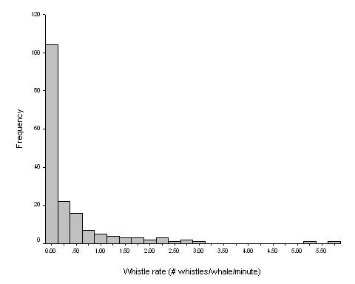
Fig. 1 Whistle rates are not the predominant call type of southern resident killer whales, therefore whistle rates are distributed non-normally, in a quasi-Poisson distribution pattern. No whistles were detected in greater than half of all observations..

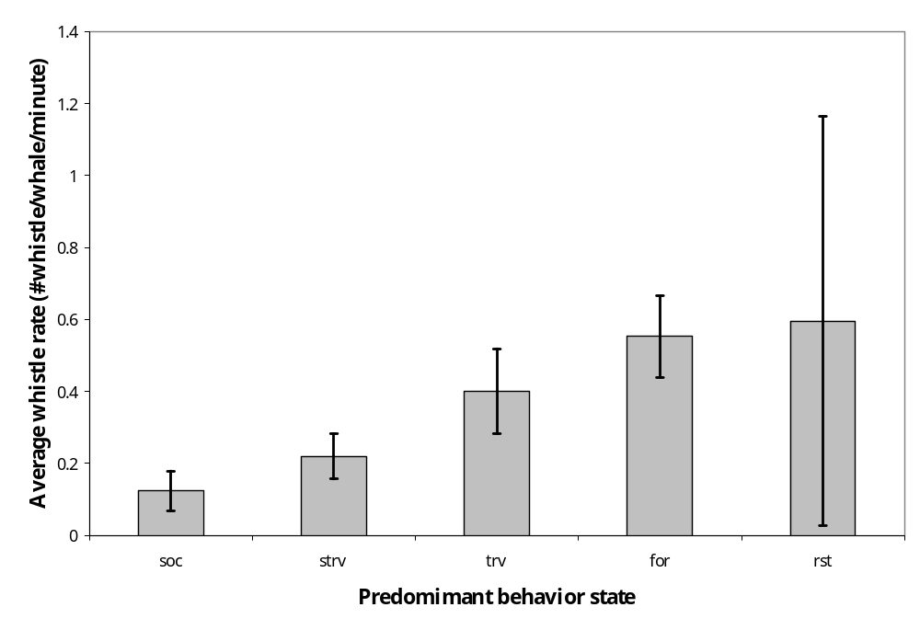
Fig. 2 Average whistle rate differed among the various behavior states in a predictable pattern. Behavior state was a reliable covariate to group spread. Note large error during rest behavior is due to small sample size (N=3).

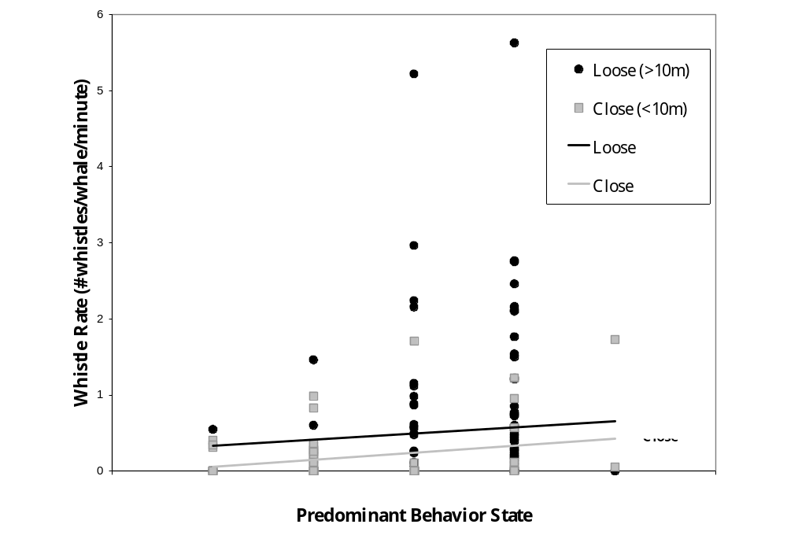

Fig. 3 Whistle rates increase similarly across behavioral states for loose and close group spread configurations, yet whistle rate is greater across all behavior states when spread is loose (>10m) than when spread is close (<10m) regardless of behavior state.

A

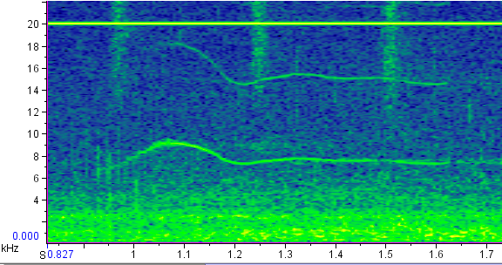
B
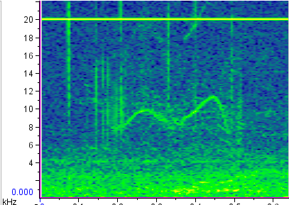

C

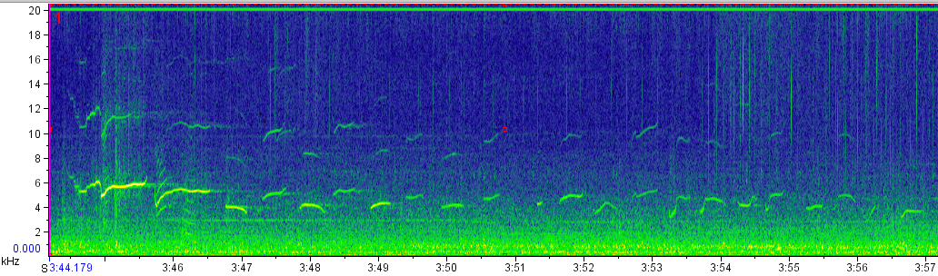

D

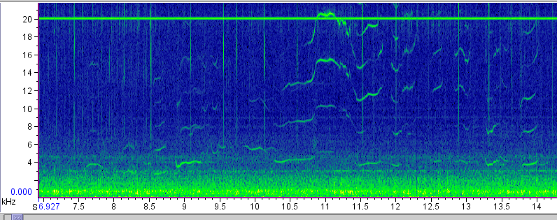

Figure 4 Spectrograms show examples of whistles (A and B) as well as whistle trains (C and D). Whistles are tonal vocalizations, typically 4-12 kHz and occur with or without harmonic structure. Time is displayed on the x-axis and frequency is displayed on the y-axis.

Literature cited:

Bigg, M. A., Olesiuk, P.F., Ellis, G.M., Ford, J.K.B., and Balcomb, K.C. 1990. Social
organization and genealogy of resident killer whales (Orcinus orca) in the coastal waters of British Columbia and Washington State. Report of the International Whaling Commission, Special Issue 12, 383-405.

Connor, R.C., Wells, R., Mann, J., & Read, A. 2000. The bottlenose dolphin: social relationships in a fission-fusion society. In: Cetacean Societies (Ed. by J. Mann, R. Connor, P. Tyack, and H. Whitehead), pp. 91-126. Chicago and London: University of Chicago Press.

Ford, J.K.B. 1987. A catalogue of underwater calls produced by killer whales (Orcinus orca) in British Columbia. Canadian Data Report of Fisheries and Aquatic Sciences, 633, 1-165.

Ford, J.K.B. 1989. Acoustic behavior of resident killer whales off Vancouver Island British Columbia, Canada. Canadian Journal of Zoology, 67(3), 727-745.

Ford, J.K.B. 1991. Vocal traditions among resident killer whales Orcinus orca in coastal waters of British Columbia Canada. Canadian Journal of Zoology, 69(6), 1454-1483.

Ford, J.K.B., Ellis, G.M., Barrett-Lennard, L.G., Morton, A.B., Palm, R.S., and Balcomb, K.C. 1998. Dietary specialization in two sympatric populations of killer whales (Orcinus orca) in coastal British Columbia and adjacent waters. Canadian Journal of Zoology, 76(8), 1456-1470.

Ford, J.K.B., Ellis, G.M., and Balcomb, K.C. 2000. Killer Whales: The natural history and geneology of Orcinus orca in British Columbia and Washington. Vancouver, British Columbia: University of British Columbia Press.

Ford, J.K.B. and Ellis, G.M. 2006. Selective foraging by fish-eating killer whales Orcinus orca in British Columbia. Marine Ecology Progress Series, 316, 185-199.

Miller, P.J.O. 2000. Maintaining contact: design and use of acoustic signals in killer whales, Orcinus orca. PhD dissertation, Massachusetts Institute of Technology, Woods Hole Oceanographic Institution.

Miller, P.J.O. 2002. Mixed-directionality of killer whale stereotyped calls: a direction of movement cue? Behavioral Ecology and Sociobiology, 52, 262-270.

Osborne, R. W. 1986. Behavioral Biology of Killer Whales. In: Behavioral Biology of Killer Whales (Ed. by B.C. Kirkevold and J.S. Lockard), pp.211-249. New York: Alan R. Liss, Inc.

Riesch, R., Ford, J.K.B., and Thomsen, F. 2006. Stability and group specificity of stereotyped whistles in resident killer whales, Orcinus orca, off British Columbia. Animal Behaviour. 71, 79-91.

Sayigh, L., Tyack, P., Wells, R., Solows, A., Scott, M., & Irvine, A. 1998. Individual recognition in wild bottlenose dolphins: a field test using playback experiments. Animal Behaviour, 57, 41-50.

Thomsen, F., Franck, D. and Ford, J.K.B. 2001. Characteristics of whistles from the acoustic repertoire of resident killer whales (Orcinus orca) off Vancouver Island, British Columbia. Journal of the Acoustic Society of America. 109(3), 1240-1246.

Thomsen, F., Franck, D. and Ford, J.K.B. 2002. On the communicative significance of whistles in wild killer whales (Orcinus orca). Naturwissenschaften. 89, 404-407.

Ethogram:

PREDOMINANT GROUP BEHAVIOR: (adapted from Osborne 1986, Bain, pers.comm., Thomsen et al. 2002)

Forage (for): typically non-directional, loose spread, slow speed, fish chases and actual prey sometimes visible

Socialize (soc): non-directional, often touching, stationary or slow speed, percussive surface behavior

Rest (rst): non-directional, often touching or close, slow or stationary speed, often seen at surface in a line as a group or subgroup, or alone ‘logging’

Travel (trv): directional, slow to fast speeds, loose spread, regular surfacings
Social Travel (strv): travel, but distance between animals <10m

PREDOMINANT GROUP SPREAD:
Spread: ≥1 adult male body length (approximately 10m)
Close: < 1 adult male body length (approximately 10m)

GROUP:
Whales within 500m of the research vessel

Data Collection:
Recording session #
Date
Observer
TimeStart/TimeStop
AudioFile Number
PhotoFramesStart/PhotoFramesStop
Pod(s):
General Location:
OTHER NOTES:

Continuous Sampling: Time, count, predominant group activity, spread, pod/matriline, photos

