FINAL PROGRAM REPORT

Project Title: Southern Resident Killer Whale Sighting Compilation 1990-2003.

Author/ Organization: Richard W. Osborne, Ph.D., Director
The Whale Museum
P.O. Box 945
Friday Harbor, WA 98250

Project Description Prepared By:
Richard Osborne, Rowann Tallmon, Jean Olson, and Robert Otis
The Whale Museum
Email: osborne@whalemuseum.org

Contract Number: AB133F-03-SE-1133 (Req. No. NFFP7000-3-00070).

Date: August 5, 2003 through July1, 2004.

Abstract:

The goal of the Southern Resident Killer Whale (SRKW) Sighting Compilation 1990-2003 was to integrate available historical sighting data from the inland marine waters of Washington State and Southern British Columbia on the Southern Resident population of killer whales into a single uniform database with spatial delineation for standard Geographical Information Systems (GIS). This project identified killer whale sighting sources, systematically evaluated sighting data sets for accuracy, entered and integrated all sighting sources into a single uniform data set in MS Access with normalized spatial locations, and translated all sighting location information into latitude and longitude, UTM coordinates, and WDFW/DFO Fisheries reporting areas, relative to The Whale Museum’s historical sighting quadrants. The four data sources for this Orca Master database are 1) The Whale Museum’s sighting archives, 2) Commercial whale-watch pager reports 3) Soundwatch program data and 4) Robert Otis’s longitudinal data set from Lime Kiln Point State Park. This database will be easy to update on an annual basis and should prove to be a cost-effective way for managers to systematically track the movements of the Southern Resident Killer Whales in the inland waters of Washington State and British Columbia. Included with this report are compact discs (CDs) of the entire 22,509-sighting data base in both MS Access and MS Excel.

Executive Summary:

The goal of the Southern Resident Killer Whale (SRKW) Sighting Compilation 1990-2003 was to integrate available historical sighting data from the inland marine waters of Washington State and Southern British Columbia on the Southern Resident population of killer whales into a single uniform data set that has been systematically assessed for accuracy and spatially correlated for immediate application to standard Geographical Information Systems (GIS).

The objectives of this project were to identify killer whale sighting sources, systematically evaluate sighting data sets for accuracy, enter and integrate all sighting sources into a single uniform data set in MS Access with normalized spatial locations, and to translate all sighting location information into latitude and longitude, UTM coordinates, and fishery management areas defined by Washington Department of Fish and Wildlife (WDFW) and Department of Fisheries and Oceans Canada (DFO) relative to The Whale Museum’s historical sighting quadrants.

The primary data source in the Orca Master database is comprised of The Whale Museum’s sighting archives of year-round public sightings called into the Whale Hotline or directly provided to Museum staff through other channels (Balcomb et al., 1980; Heimlich-Boran, 1988; Felleman et al., 1991; Osborne, 1991; 1999; Olson, 1998). Sources of the latter include reports from Center for Whale Research staff, Orca Network e-mail reports, sighting compilations from independent investigator Mark Sears, and occasional data sets from Susie Washington-Smyth of the Gulf Islands sighting network and Ron Bates of the Marine Mammal Research Group in Victoria. Other more systematic data sources collected during the summer season include: Robert Otis’s longitudinal data set from Lime Kiln Point State Park (Osborne, 1999, Osborne et al, 2001), Soundwatch Boater Education Program 30-minute samples during vessel patrols (Koski et al, 2001), and pager reports on whale locations sent out to subscribing commercial whale-watch operators (Olson et al, 2001; Osborne et al, 2001).

The Whale Museum’s sighting archive data was collected in a fashion that is not subject to a uniform test of reliability due to the large variety of sighting platforms, observers, and the variation in their qualifications (Heimlich-Boran, 1988; Osborne, 1991; 1999; Olson, 1998). However the systematic summer data sets from Lime Kiln Point State Park, the Museum’s Soundwatch Program, and the commercial pager records are probably systematic enough to use as homogeneous samples on their own for some statistical considerations, but not in combination with each other.

Seasonally there are extreme sampling biases in terms of 1) number of observers, 2) number of observers actively searching for whales, 3) period of daylight, and 4) visibility in terms of sea surface and atmospheric conditions. For summer data (May-August) the bias of all these variables has been minimized close to zero in recent years (since 1992) as a result of the huge increase in (commercial) observer effort, coupled with the consistently ideal environmental conditions for detecting killer whales during those months. Outside of the summer months all the variables of potential bias become problematic (Osborne, 1999).

Though all the data has been given with a point source, killer whale movements cover large areas and the original location sources are often approximate. The data can be used with a 2 kilometer cell in a standard GIS application.

Included with this report are compact discs (CDs) of the entire database in both MS Access and MS Excel. This final program performance report on disposition of funds from Grant Award Number AB133F-03-SE-1133, entitled Southern Resident Killer Whale (SRKW) Sighting Compilation 1990-2003 fulfills reporting requirements under the NOAA Administrative Terms and Conditions of the award.

Project Goal:

The ultimate goal of this project was to compile the available historical sighting data from the inland marine waters of Washington State and Southern British Columbia on the Southern Resident population of killer whales into a single uniform data set that has been systematically assessed for accuracy and spatially correlated for immediate application to standard Geographical Information Systems (GIS).

Project Objectives:

The objectives of the Southern Resident Killer Whale (SRKW) Sighting Compilation 1990-2003 were to:

- Identify SRKW sighting sources.
- Systematically evaluate SRKW sighting data sets for accuracy.
- Enter and integrate all sighting sources into a single uniform data set in MS Access with normalized spatial locations using the Boran/Olson historical sighting quadrants.
- Translate sighting location information into latitude and longitude, UTM coordinates, and WDFW/DFO Fisheries reporting areas, in addition to the sighting quadrants.

Project Results:

The original project proposal listed several deliverables including:

- 3.1 Final report on the Orca Master database for 1990-2003.
  - 3.1.1 Table listing sighting date, time, and location and where possible pod identity and direction and how these variables are defined.
  - 3.1.2 Evaluation of financial resources for the project and its potential effectiveness for facilitating management and conservation of the population.
- 3.2 Presentation of the results at NOAA-hosted workshops.
- 3.3 Electronic submission of the database or its summary.

    - Data Sources and Field Descriptions

The source information for each of the four data sets comprising Orca Master 1990-2003 are identified in Table 1 including a basic description of the data set, periods of coverage, locations, and numbers of records. In Table 2 each field in the database is described and classified in terms of the data type, its format and its rules for entry.

Table 1: DATA SOURCES

DATA Source | Years | Description | Location Record | Record Source Code | No. of Records
TWM Sighting  Archive | 1990-2003  Year-round | Sighting records reported by public and reliable observers to TWM | Locations given in descriptive terms and matched to TWM Quadrants. | TWM-SA-Pub  TWM-SA-Rel | 4358  3167  7525
Pager | 1997-2003  Summers | Whale-watch pager system | Pager coordinates matched to TWM Quadrants | TWM-Pager | 10,721
Soundwatch | 1998-2003  Summers | Sightings observed by Soundwatch personnel recorded every half-hour on the water. | TWM Quadrant | TWM-SW | 3203
Lime Kiln Station | 1991  1994-2003  Summers | Sightings by Dr. Robert Otis, Ripon College May-Aug every day from 9-5. | Lime Kiln study area is TWM Quadrant 181 | TWM-Otis | 1060

Data Sources

In Table 1 the first data source is The Whale Museum’s sighting archives. The Whale Museum has long maintained an archive of marine mammal sightings. These sightings are reported to the Museum by several channels, including the Whale Hotline (a phone recording for public sightings), Orca Network (an e-mail list service based on Whidbey Island), e-mail through the Museum’s web site and eyewitness reports from Museum staff and visitors. Sightings are recorded on a data sheet and then typed into a Microsoft Access database. Sighting Archive records are identified as a public source if the observer is not known to Museum staff; records are identified as reliable if the observer is known to be experienced or professional. Observations from whale-watch operators and naturalists, TWM staff and interns, the Center for Whale Research, Puget Sound independent investigator Mark Sears, Ron Bates of the Marine Mammal Research Group in Victoria, B.C., and Susie Washington-Smyth of the Gulf Islands sighting network are identified as reliable. The sighting archive is the only data source that contains year-round data.

The second data source is the pager data provided by SeaCoast Expeditions of Victoria, B.C. Observations of whale movements are taken primarily from Mt. Douglas on Vancouver Island and transmitted to commercial whale-watch operators using an electronic pager. The commercial operators also communicate with the pager personnel to keep close track of the whales. This data is usually recorded at the end of each day by Soundwatch crew in a notebook. In some years the pager personnel kept records that were then photocopied. The notebooks and photocopies were then entered into Microsoft Access by TWM research fellows. The pager data is only available during the whale-watch season, May through October.

The third data source is Soundwatch data. The Whale Museum runs the Soundwatch Boater Education program to distribute educational literature to private whale-watch boats and collect data on the vessel traffic around the whales. Every half-hour Soundwatch personnel count boats around the whales and note the time, location, pod and direction of the orcas. This data is collected on field data sheets designed for this purpose and then is entered into a Microsoft Access database. Soundwatch data is also only available from the regular whale-watch season.

The final source of data is Robert Otis’s longitudinal data set from Lime Kiln Point State Park. From late May until early August, Dr. Otis and his interns record data about the whales as they pass by the park in the hours between 9 a.m. and 5 p.m. This is a very important data set in establishing a uniform observer effort and helping distinguish pod turnarounds in Haro Strait.

Field Descriptions

In Table 2 the description of the fields in the database are outlined.

Date information is included in a short date field and split out to month/day/year for ease of sorting the data.

Time is included both as a short time field and as an integer to accommodate different types of software that might be used in the analysis of this data.

Pod identity is included where known. When pod identity was not known “Orcas” is listed as the pod. Unknown pods may not be Southern Residents, but known sightings of transients, offshores, and northern resident orcas have not been included in this data set.
On occasion a subgroup of L-pod was noted. “L12” is used to designate the L12 group which means no other L-pod whales were seen. “LM” indicates there were L-pod whales but none of the members of the L-12 group were seen. This information is only known sporadically, but it was included for its importance to understanding SRKW travel patterns.

Direction is the heading of the whales at the time of observation and is indicated as a text field with N for north, E for east, etc. Whale turnarounds are indicated by the word “then” as in “N then S”. Non directional behavior is listed as “mill”.

Location is described in 4 distinct ways: TWM Quadrants; WDFW/DFO Fishery Areas, UTM coordinates and latitude/longitude. All of the location data from each of the data sources was matched from their original description to the Museum’s quadrant system (Heimlich-Boran 1988, Olson 1998).

The location data for the Sighting Archive data originally consisted of descriptions of the area where the animals were seen, usually referring to a point on land. Locations from the Pager data were reported on a grid system used by the whale-watch operators. Soundwatch data was originally reported in TWM quadrants and Lime Kiln data is TWM quadrant 181.
Using the centroid of each quadrant Jean Olson obtained UTM coordinates using 10 North. These were then also described in terms of latitude and longitude (Olson et. al. 2001).

Additionally all the observations are assigned to fishery management areas to facilitate larger groupings of data. All U.S. sightings are assigned to Washington Department of Fish and Wildlife (WDFW) fish areas (Figure 2). All B.C. sightings are assigned to Department of Fishery and Oceans Canada (DFO) fish areas (Figure 3). The letter “C” is appended to the DFO fish areas to indicate that the sighting is from Canada.

Source is the original data source for the record as identified in Table 1. TWM-SA for Museum sighting archive, TWM-Pager for pager data, TWM-SW for Soundwatch data, and TWM-Otis for Dr. Otis’s Lime Kiln data.

Table 2: FIELD DESCRIPTIONS

FIELD | Data Type | Format | Description | Format Example /Rules of Entry
Date | Date | 11/16/2001 | Date of observation | 11/16/2001
Time1 | Time | 13:00 | Time of observation | 13:00
Time2 | Long Integer | 1300 | Time of observation | 1300
Month | Long Integer | 11 | Month of observation | 11
Day | Long Integer | 16 | Calendar day of observation | 16
Year | Long Integer | 2001 | Year of observation | 2001
Pod | Text |  | Pod identity | J J-Pod members  K K-Pod members  L L-Pod members  JKL J,K, and L-pod members traveling together  L12 L12 subpod  LM Main part of L-pod without the L12 subpod  Orcas Pod identification not known  J? Uncertain pod identification
Dir | Text |  | Direction whales seen heading | N North  N then S Whale turnaround  mill Non directional/ milling
FishArea | Text |  | WDFW Fish Areas -US  DFO Fish Areas-BC | WDFW Fish areas 1-13 Figure 2  DFO Fish Areas 12C-29C Figure 3
Quadrant | Long Integer |  | TWM Quadrants 1-445 | TWM Quadrants 1-445 Figure 1
Lat | Double |  | Latitude of quadrant centroid | In decimal degrees
Long | Double |  | Longitude of quadrant centroid | In decimal degrees
UTMx | Double |  | 10 North UTM coordinate
UTMy | Double |  | 10 North UTM coordinate
Source | Text |  | Source data for record | TWM-SA-Pub Public info from TWM Sighting Archive  TWM-SA-Rel Reliable info from TWM Sighting Archive  TWM-Pager Whale-watch pager data  TWM-SW Soundwatch observation  TWM-Otis Otis data from Lime Kiln Point State Park

    - Evaluation of Financial Resources

In Table 3 the breakdown of basic expenses is presented. Consulting expenses are paid out to the two primary sources of SRKW sightings that are not directly affiliated or otherwise compensated by The Whale Museum. These include Mark Sears who, from his base at Lincoln Park in West Seattle, has tracked and identified SRKWs in cooperation with the Museum’s hotline since 1978, and Orca Network, which since 2001 has increasingly become “orca sighting central” for the habitat range of SRKWs through its e-mail network and web site.

In addition to compensating the consultants for their contributing data, the actual records still need to be obtained by Museum staff and volunteers through answering machine messages, e-mail alerts, hourly pages with short life spans, and photocopied monthly/yearly compilations. On a weekly basis the bulk of incoming sightings are entered into the Orca Master database by Museum staff. During the fall and winter Museum staff members secure compiled data sets from Dr. Otis, Mark Sears, Soundwatch, and cooperating community groups and integrate them into Orca Master.

Table 3 EXPENSE SUMMARY

Budget Item | Rate | Hrs | Amount
Consulting Expenses
-Mark sears |  |  | $5,000.00
-Orca Network |  |  | $5,000.00
Weekly entering of incoming sightings (One Year = 156 hours) | 3 hrs/wk @ $25/hr | 156 | $3,900.00
Compilation of existing data sets | $25/hr | 150 | $3,750.00
Data Entry 40 hours (+ 40 volunteer) | $25/hr | 40 | $1,000.00
25 hours final data base massaging | $25/hr | 25 | $625.00
Report preparation | $25/hr | 10 | $250.00
 |  |  | ($19,525.00)
Institutional Overhead | 2.4% |  | $475.00
 |  |  | $20,000.00

The historical compilation component of the present contract required more staff time than anticipated. The extra staff time was subtracted from the institutional overhead to make up the difference. In the future these additional hours will not be needed to annually update the now existing database.

Maintaining this database on an annual basis is a cost-effective way of tracking pod movements without tagging the animals or employing additional field operations. It also provides a central spatial resource without ambiguity because all scientists and managers are working from exactly the same data set. With the submission of this report a historical centralized universal data set on SRKW movements will be freely available to all investigators, allowing their varying analyses to be based upon exactly the same information. It is estimated that this data set can be updated by the grantee for about $20,000 a year under present subcontractor agreements and economic conditions. Since access to the data set can be made freely available by the federal government in electronic form and will also eventually be made available through the Museum’s web site (www.whalemuseum.org) there shouldn’t be any additional expenses associated with its dissemination.

  - Presentations of Findings and Works in Progress

Preliminary presentations of this data set were made at the NOAA-sponsored Southern Resident Killer Whale Workshop January 19th – 23rd, 2004, and the Southern Resident Killer Whale Behavior Coding Workshop, April 20th, 2004. Preliminary data sets were made available for student projects at the University of Washington Friday Harbor Laboratories in 2003 (Hauser, 2003; Heydenreich, 2003) and are presently incorporated in two thesis projects at the University of Washington. A poster presentation for one of them has been accepted for the upcoming Puget Sound/Georgia Basin Research Conference (Hauser et al, 2005). Future publications and additional presentations utilizing this data set and its updates are planned. These presentations include upcoming workshops for the Canadian Department of Fisheries and Oceans (DFO), as well as the Washington State Department of Fish and Wildlife (WDFW) and NOAA.

  - Summary Copy of Data

The primary product of this contract is the 22,509 sighting records of SRKWs that have been systematically assessed and integrated into a single spatial database available to GIS. This has been provided on CD to the Northwest Fisheries Science Center. Additional CD copies are being provided to all collaborators, and will be made permanently available for downloading on The Whale Museum’s web site (www.whalemuseum.org) in 2005.

Individuals and/or Organizations that Collaborated with the Grantee and Performed the Work:

The Whale Museum staff administered grant funds, including accounting and disbursements, from award AB133F-03-SE-1133, and undertook the bulk of sighting recording, compilation and assessment. Individuals who made major contributors to the compilation and assessment of the database include Jean Olson, Kari Koski, Bob Otis, Diane Gardetto, Johanna Smith, Jodi Smith, Sean Harrington, Donna Hauser, Christi Diamond and Monica Weiland. Special thanks also go to the primary contributors of sightings Mark Sears, Bob Otis, Orca Network, SeaCoast Expeditions, the Center for Whale Research, the Soundwatch program, Suzy Washington-Smyth and the Gulf Islands Sighting Network, and Ron Bates and the Marine Mammal Research Group.

REFERENCES

Balcomb, K.C., J.R. Boran, R.W. Osborne, and N.J. Haenel, 1980.
Observations of Killer Whales (Orcinus orca) in Greater Puget Sound, State of
Washington, NTISPB80-224728, U.S. DEPT. OF COMMERCE, Springfield,
VA.
Felleman, F.L., J.R. Heimlich-Boran, and R.W. Osborne, 1991.
Feeding Ecology of the Killer Whale, (Orcinus orca). In: K.W. Pryor and K.S.
Norris (Eds.), DOLPHIN SOCIETIES:DISCOVERIES AND PUZZLES,
Berkeley, University of California Press, 113-147.
Hauser, D.D., 2003.
Seasonal Habitat Use, Including Areas of Pod Overlap and Specialization by Southern Resident Killer Whales (Orcinus orca) in Washington State and British Columbia. Student paper, Field Methods in Marine Mammalogy, University of Washington Friday Harbor Laboratories, Friday Harbor, WA, 24 p.
Hauser, D.D., M.L. Logsdon, E.E. Holmes, G.R. VanBlaricom, and R.W. Osborne, 2005.
An issue of scale: characterizing summer distribution patterns of Southern Resident killer whales (Orcinus orca). Abstract for a poster presentation, Puget Sound Georgia Basin Research Conference, March, 29th to 31st, 2005.
Heimlich-Boran, J.R., 1988.
Behavioral Ecology of Killer Whales (Orcinus orca) in the Pacific Northwest, CANADIAN JOURNAL OF ZOOLOGY, 66:565-579.
Heydenreich, E., 2003.
Movement Patterns of a Southern Resident Pod of Killer Whales (Orcinus orca) in Greater Puget Sound. Student paper, Field Methods in Marine Mammalogy, University of Washington Friday Harbor Laboratories, Friday Harbor, WA, 20 p.
Koski, K.L., R.W. Osborne, and R.E Tallmon, 2001. Community-Based Whale Watching Management in the U.S./Canadian Boundary Waters of Haro Strait. Whale Watching Impacts Workshop, FOURTEENTH BIENNIAL CONF. ON THE BIOL.MAR. MAMML., Vancouver, B.C., December, 2001.
Olson, Jean M., 1998.
TEMPORAL AND SPATIAL DISTRIBUTION PATTERNS OF SIGHTINGS
OF SOUTHERN COMMUNITY AND TRANSIENT ORCAS IN THE INLAND
WATERS OF WASHINGTON AND BRITISH COLUMBIA. M.S. Thesis,
Huxley College of Environmental Studies, Western Washington University,
Bellingham, WA.
Olson, Jean M., R.W. Osborne, and K.L. Koski, 2001.
GIS Plots of Five Seasons of Killer Whale Movement Patterns Using Commercial Whale Watch Sighting Network Data. Abstract, Remote Sensing Workshop, FOURTEENTH BIENNIAL CONF. ON THE BIOL.MAR. MAMML., Vancouver, B.C., December, 2001.
Osborne, R.W., 1991.
Trends in Killer Whale Movements, Vessel Traffic, and Whale Watching in Haro Strait. PROCEEDINGS OF PUGET SOUND RESEARCH '91, Seattle, WA.,
Puget Sound Water Quality Authority, pp.672-688.

Osborne, R.W.,1999.
A HISTORICAL ECOLOGY OF SALISH SEA RESIDENT KILLER WHALES (Orcinus orca) WITH IMPLICATIONS FOR MANAGEMENT. Doctoral thesis, Dept. Geography, University of Victoria, Victoria, B.C., 262 p.
Osborne, R.W., J.M. Olson, and R.E. Tallmon, 2001. Southern Resident Killer Whale Habitat
Use at Different Time Scales Using Sighting and Photo-Identification Records. Abstract, FOURTEENTH BIENNIAL CONF. ON THE BIOL.MAR. MAMML., Vancouver, B.C., December, 2001.

* * *

Figure 1: The Whale Museum marine mammal sighting Quadrants. (Heimlich-Boran 1988, Olson 1998)

Note: This map is formatted to print on 11 x 17 paper. For a better view and to print it out correctly please view file TWMQuads.doc included on this CD.
Figure 2: Washington Department of Fish and Wildlife fishery management areas

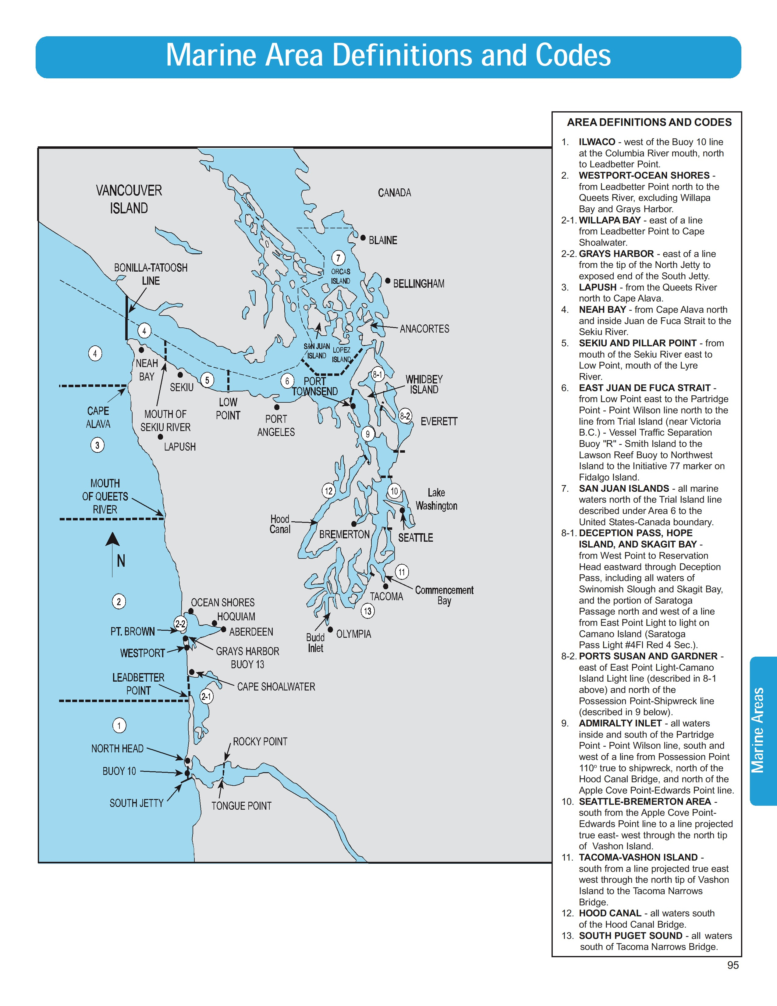

Source: Washington Department of Fish and Wildlife, Sport Fishing Rules 2004/2005
Pamphlet edition. http://wdfw.wa.gov/
Figure 3: Department of Fisheries and Oceans Canada fishery management areas.

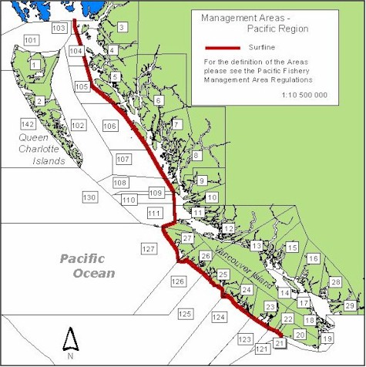

Source: Fisheries and Oceans Canada
www.pac.dfo-mpo.gc.ca/ops/fm/Areas/area-map_e.htm

